 | Year 4
 | Autumn Term |  |  | Spring Term |  | Summer Term
English Book | Angel of Nitshill Road | The Iron Man |  | Why the Whales Came | How to Train Your Dragon | Journey to Jo’burg | The Matchbox Diaries
Maths | Place Value  Addition and Subtraction  Measure: Perimeter  Multiplication and Division |  |  | Multiplication and Division  Measure: Area  Fractions  Decimals |  | Decimals  Money  Time  Statistics  Geometry
Science  OW | States of Matter | Animals including Humans |  | Sound | Animals and their habitats | ELectricity | History of Science
History | Roman Republic | The Roman Empire |  | Roman Britain | Christianity in Three Empires | Arabia and Early Islam | Cordoba: City of Light
Geography | The Rhine and the Mediterranean | Population |  | Coastal processes and landforms | Tourism | Earthquakes | Deserts
Computing | iData |  | iMail | Micobits (MGL) | iProgram (Unit 2 and 3) | iMovie | iAnimate
Physical Education | Tag Rugby |  | Gymnastics | Tennis | Tennis | Dance | Athletics
Music | Mamma Mia – Pop |  | Glockenspiel 2 | Stop – Grime | Lean on Me - Gospel | Blackbird | Reflect
Design and Technology |  |  | Levers and Linkages – Roman Catapult |  | Tourism world kitchen |  | STEM - aquaducts
Art and Design | Textiles/collage – Roman weaving wall |  |  | Drawing – coastal drawing line & tone (Frank Dekkers) |  | Sculpture – coiled pot
Spanish | Description of hair and eyes  Brothers and sisters  Number and Time  School subject and opinions  Alphabet |  |  | Weather  Animals and habitats  Number |  | Sports and opinions  Days and Seasons  Number and money  Food
PSHE | Being Me in my world |  | Celebrating difference | Relationships | Healthy me | Dreams and goals | Changing me
Enrichment/Visits/Visitors/ | Chester: Romans |  |  | Crosby beach – landforms  Cathedral/Church visit |  | Al-Rahma Mosque
Cultural Enrichment | Explore paintings by George Stubbs (Liverpool artist)  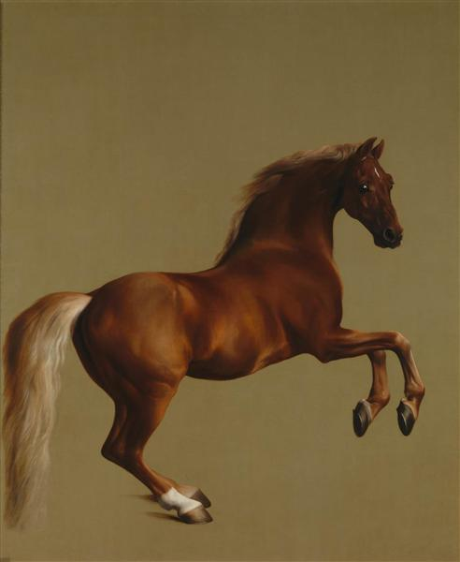 |  |  | Listen to and appraise Vivaldi – Four Seasons: Spring.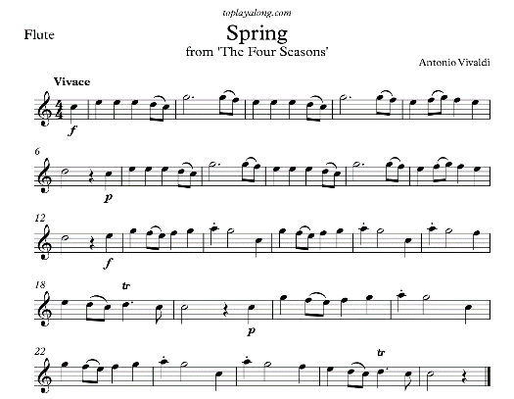 |  | Famous mathematicians  https://nrich.maths.org/famous-mathematicians

