 | Marvellous Me | Let’s Celebrate | Heroes | Brilliant Beasts | The Great Outdoors | Explorers
Possible Lines of Development |  | Looking at different Cultures  Christmas Celebrations | Superhero’s  Police  Fire  Doctors  Coastguard | Dinosaurs  Dragons and Knights  Minibeasts  Traditional tales | Planting  Minibeasts  Birds | Pirates  Oceans  Astronauts  Looking after our planet
Special Events and wow experiences | Harvest festival  Recycle Week  World Mental Health Day  Teddy Bears Picnic | Nursery Rhyme Week  Bonfire Night  Remembrance Day  Diwali  Stanley Park Visit  Christmas | Heros dress up day.  Pancake Day  Chinese New Year  Valentines Day  Children’s Mental Health Week  Weather/ Ice | Reptile visit  Easter Celebrations  Eid  Mothering Sunday | Earth Day  Pride  Planting our own seeds  Acorn Farm Visit | World Oceans Day  Fathers Day  Graduation
Vehicle Text | 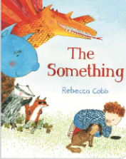 | 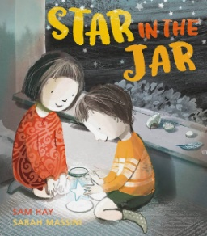 | 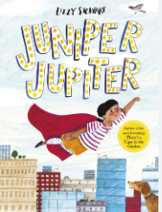 | 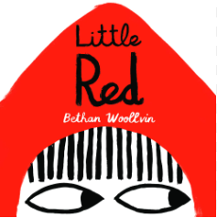 | 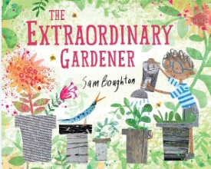 | 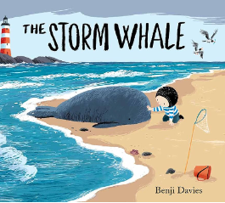
Core Texts | 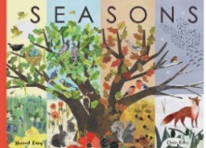  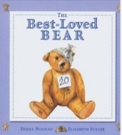  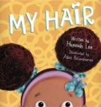  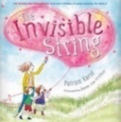  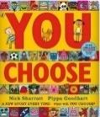  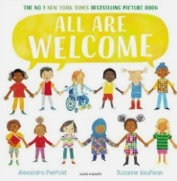  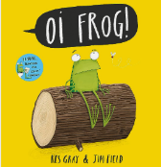  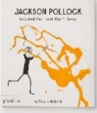  NEEDS MATHS BOOK  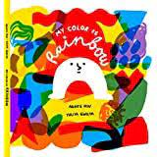  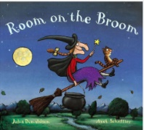  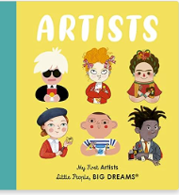  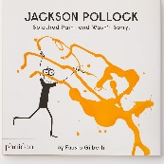  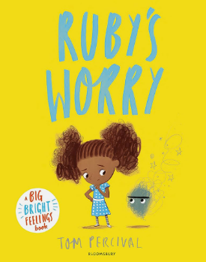  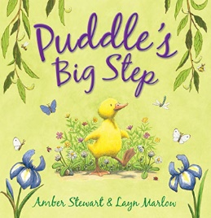 | 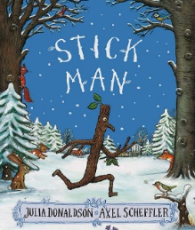  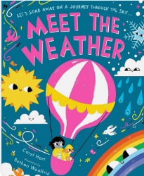  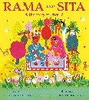  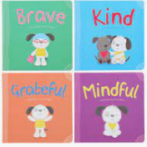  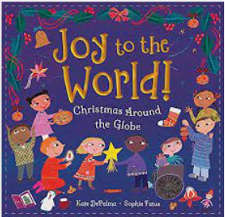  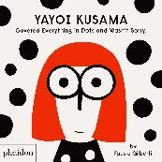  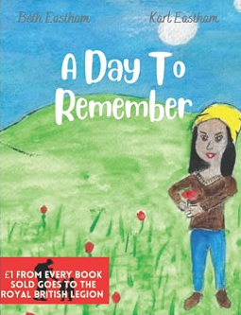  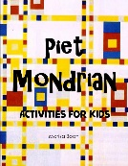 | 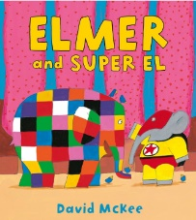  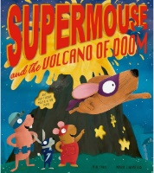  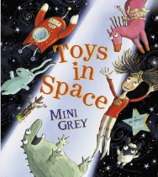  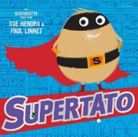  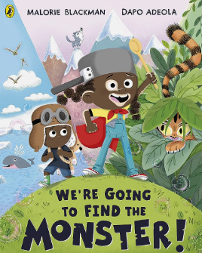 | 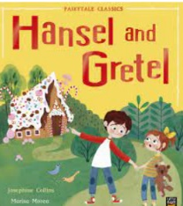  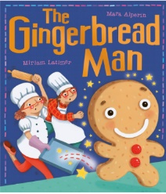  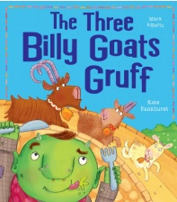  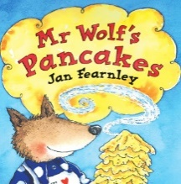  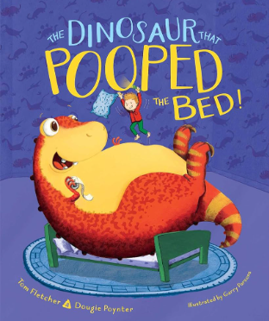  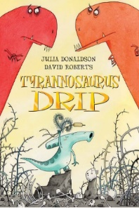  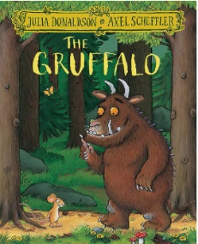  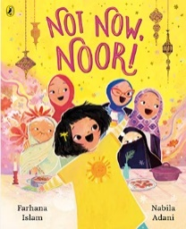  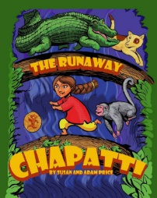  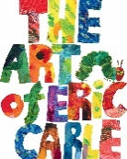  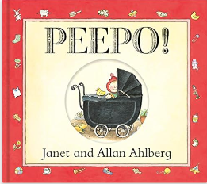 | 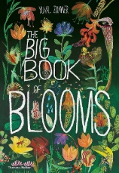  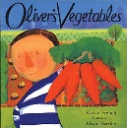  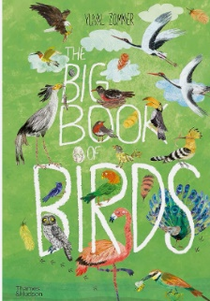  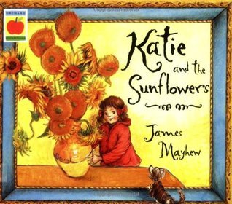 | 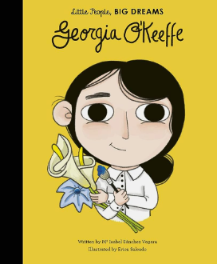  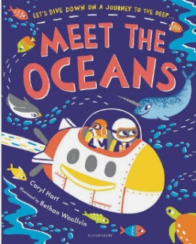  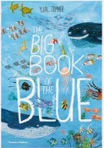  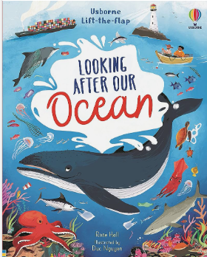  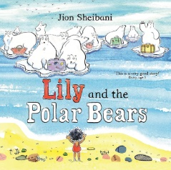  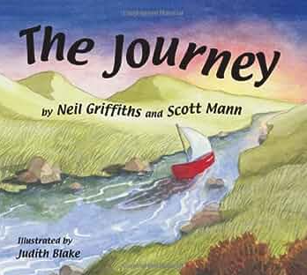  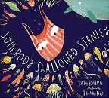  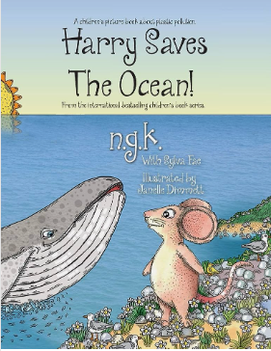  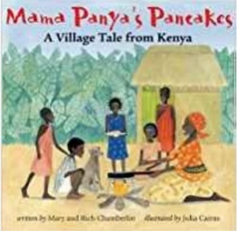  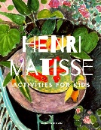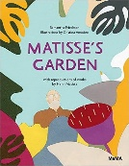  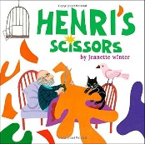
Parental Involvement | Family Photographs  Phonics Stay and Play  Family Challenge – Signs of Autumn | Parent Helpers for Stanley Park  Christmas Performance | Family Challenge – Timeline | Mathematics  Stay and play | Writing Stay and Play | Reception Graduation  Sports Day
Development of Expressing Feelings  (Self-Regulation)  Intent  Vocabulary  Implementation | Children talk about their feelings to trusted adults or special friends.  Feelings, emotions, happy, sad, angry, good, bad.  Books read focusing on feelings and emotions (see core texts). Class discussions on emotions – particularly relating to starting school and linking to the zones of regulation. | Children are sharing more often or may comfort a friend who is upset. Children identify their own emotions and name them.  Happy, sad, angry, upset, cry, nice, problem, feeling, emotions.  Books read around sharing, friendships, conflicts. Adults modelling resolving conflict. Adults asking children to express their feelings. | Children who are very upset know who they can talk to or know some ways to calm themselves down if needed. Children are becoming more proud of themselves for achieving things such as receiving a team certificate.  Proud, pride, happy, breathing, feel, feelings, emotions, happy, sad.  Adults giving children time to present any achievements and children knowing they can talk to their teachers about the achievements they have made. | Children have an adult in school they trust and will talk to. Children talk about their interests and likes and dislikes at school.  Choice, explain, say, worry, sad, help.  Adults prompting children to explain the choices they have made. Children spending time with their key worker in their classroom so they feel comfortable to talk about any concerns they may have. | Children try and share, take turns, reason and look after one another. They apologise if they hurt someone accidently or make someone else upset.  Sorry, upset, sad, accident, help.  Adults modelling apologies and explaining to children when an apology is necessary. | Children show emotional maturity ready for the emotional resilience needed for KS1. Children can use reason and resolutions with other children to keep games and play fair.  Emotion, feeling, happy, sad, frustration, explain, why, turn taking, my turn, your turn.  Adults providing children with a range of strategies to deal with anger and other emotions.
Development of Managing behaviour  (Self-Regulation)  Intent  Vocabulary  Implementation | Children may come into school upset but can be comforted by adults. Children listen to the rules and expectation and begin to follow them.  Upset, sad, feeling, emotion, rules, safety.  Adults supporting children who are upset. School behavioural expectations explained to the children. Behaviour expectations explained as well as the reason behind them – books shared linked to rules. | Children begin to take turns and share resources and are developing patience and understanding that there is more than just them in the class.  Sharing, taking turns, my turn, your turn, patience, waiting.  Adults modelling sharing, adults supporting children to share in small groups. | Children know and follow the behavioural expectations of the school.  Rules, following, behaviour (language related to the relationships policy)  Behaviour expectations are consistently shared with the class. | Children are beginning to understand why listening is important to help us learn and keep us safe.  Listening, waiting, trusted adults, friend, friendship, safe, safety.  Adults consistantly to model and explain why we listen and why it is important. Stories shared around listening using visual prompts if necessary. | Children will without question follow instructions from their teachers or school adults.  Listening, rules, following, safety (language relating to the behaviour policy)  Adults giving children clear instructions in a range of situations to follow. | Children are developing in independence and can manage their behaviour in a range of situations in school.  Independence, getting on, planning, changing, keeping on trying, reflecting,  Challenges available to the class. A wide selection of provision available for children to choose between. Adults prompting children to explain their progress in their play.
Development of Self-awareness, keeping healthy (Managing Self)  Intent  Vocabulary  Implementation | Children are developing an awareness of themselves and are forming their own opinions. Children are beginning to learn the classroom rules and are following these with some reminders.  Like, dislike, rules, listening, safe, behaviour.  Prompting children to explain what they like and dislike. Rules and expectations explained and modelled to the class. Prompts to follow the rules – verbally and pictorially. | Children are doing things for themselves – because they want to. They will say what they are doing and why they are doing it too.  Why, explain, language linked to provision and prior learning.  Prompts to discuss what they are doing and give a reason why. | Children have a good understanding of the behaviour expectations and guide others to follow. They are proud of what they can do and their achievements.  Happy, proud, like, better, improve, good, bad, right, wrong, behave, rules, follow.  Children given time to talk to adults or as a ‘show and tell’ to explain their achievements. Children discussing the rules and knowing right from wrong. | Children know what makes them happy and do these things, they know what keeps them healthy and will do these things when possible.  Show and tell, proud, happy, achieve, healthy, physical activity, tooth brushing, screen time.  Stories and lessons based on keeping healthy including tooth brushing, physical activity, screen time and healthy eating. | Children tell adults and their peers what they have achieved and what they can do now, they are happy with themselves and proud of what they have achieved at school.  Happy, good, like, proud, I can, better.  Children given time to talk to adults or as a ‘show and tell’ to explain their achievements. | Children are proud of who they are and what they can do. They talk about themselves positively.  Individual, me, my, I can, happy, good, like, better.  Discussions with adults on their achievements in Reception and how they have progressed since joining school as part of the Graduation celebration.
Development of Independence (Managing Self)  Intent  Vocabulary  Implementation | Children are becoming more independent at coming into school in the morning and getting ready for home at home time. They are using the toilet independently most od the time at school. They know it is okay to ask for help and will do so.  Get, book bag, water bottle, pack-up, timetable, toilet, wiping, listening.  Visual and verbal reminders to organise themselves. Reminders to use the toilet, although children should be going independently but may need some verbal support. Adults giving children simple and clear 1 step instructions such as “Get your bag”. | Children are using their preferences to choose what they would like to do at school. Children can put their coats on and are becoming more confident and skilled in using buttons and zips.  Play, playing, area names of the classroom, help, please, dress, undress, clothing names, listening, next.  Children given the choice to play in the area they would like to in the classroom. Adults to build up relationships with the class so they feel comfortable to ask for help. Verbal and pictorial reminders and support to get changed. | Children are becoming much more independent – getting things for home, eating their dinner and snacks, asking for help, getting a drink when they want one. Children independently making healthy food choices such as at dinner time.  Toilet, food, drink, knife, fork, help, tired, poo, healthy, treat food.  Adults to build a good relationship with the class so they feel comfortable to ask for help or express their needs. Lessons and activities based around heathy and unhealthy foods. | Children looking after themselves at school (personal and hygiene needs). Children developing resilience and perseverance independently.  Dress, undress, zip, button, help, try again, tricky, hard, challenge, safe, road safety, look both ways, listening.  Children being asked to independently dress themselves. Children given challenges in class. Children having to explain how to be safe on roads and paths or being taken out of school as a class on a walk. | Children are confident to try new things. They continue to develop their resilience and perseverance independently. Children can continue to look after and care for themselves.  Like, dislike, why, explain, reason, resilience, try again, rule, road safety, directions, listen, next, after that.  Regular new activities introduced to the class. Discussions around resilience and perseverance. Discussions around road safety or a class walk. | Children continue to look after themselves and understand what healthy choices are. Children have developed resilience, independence and perseverance to support them through transition and the next step in their school journey.  Challenge, harder, next level, healthy, food groups, fats, proteins, carbohydrates, dairy, food names, physical activity, P.E, work out.  Challeneges in the classroom and during adult guided work. Discussions and lessons around keeping healthy.
Development of Social skills (Building Relationships)  Intent  Vocabulary  Implementation | Children are building new positive relationships with pupils and staff in their new setting. They may begin to play alongside other children if ready.  Friend, teacher, peer, class, others, happy, talk, conversation, play, group, roleplay, small world.  Giving children lots of opportunities to talk during carpet time, group tasks, playing, and general discussions. Conversations modelled by adults. | Children are building on the relationships started last term. They are talking to children and adults in their setting and beginning to ask for help if they need it.  Friend, class, teachers, help, please, talk, conversation.  Adults modelling respectful conversations through play, adults building positive relationships so children feel comfortable to ask for help. | Children have friendships and may have a special friend. They play with these children in and out of the classroom and are happy to  Talk, friends, friend names, play, classroom area names.  Children provided with lots of opportunities to play with others and make friends with other children. | Children are building relationships through play and talk and conserve to many of their peers.  I think, because, why, when, please, turns, next, shall we, pretend.  Adults modelling negotiation, children supported to negotiate and play. Lots of opportunities for children to play. | Children continue to build strong bonds with other children in their school and care for their peers e.g. getting them tissues, asking them to join in with a game.  Do you, like, dislike, your turn, my turn, minutes, shall we.  Stories around considering others, prompts to share, collaborate with other children if necessary. | Children know if they have hurt someone’s feelings and will apologies without being asked. Children know some children might like or dislike the things they do and that it is okay. Children look after each other and want to help their friends. Your turn, my turn, you can have it, share, sad, happy, friend.  Stories around conflict, responsibility, individuality and needs of others.
Development of Communication (Building Relationships)  Intent  Vocabulary  Implementation | Children will develop their personal, social and emotional skills throughout the Reception year and these skills are taught through significantly adult modelling and guidance.  Children will pick up on adults language used, vocabulary, mannerisms, tone of voice, verbal and non-verbal communications and therefore adapt these into their own communication.  Teacher, peer, friends, class, nicely, turn taking, having a go.  Adults modelling conversations to other adults as well as to the whole class, small groups of children and 1:1 with children too. Adults using specific facial expressions to convey emotions for children to see as well as using appropriate language and vocabulary that they would like for the children to also use. Adults will model positive engagements.
Ongoing Communication and Language skills developed throughout the year | - Children will continue to learn new vocabulary and its meaning.  - Children will continue to use new vocabulary in conversations and discussions – with teachers and peers.  - Children will continue to learn new rhymes, poems and songs – some of which they can recite from memory
Development of Listening skills  Intent  Vocabulary  Implementation | Children are beginning to listen to other children in their setting. They listen during story time and show an interest in the books being read.  Listen, reading, wait, turn, story, caret time, join in, hand up, question, song, rhyme, poem.  Carpet time with ongoing verbal and visual reminders to listen to others, daily and weekly songs, rhymes, music and stories shared. | Children are listening more on the carpet and when being spoke to by their teacher and peers. Children continue to listen to new stories that are shared with them.  Listen, reading, wait, turn, story, caret time, join in, hand up, question, song, rhyme, poem.  Assembly time, Carpet time with verbal and visual reminders to listen to others, daily and weekly songs, rhymes, music and stories shared. | Children’s listening skills are continuing to develop and they are listening in lots of different situations such as carpet time, phonics and other lessons.  Listen, looking, thinking time, reading, wait, turn, story, caret time, join in, hand up, question, song, rhyme, poem.  Carpet time with verbal and visual reminders to listen to others, daily and weekly songs, rhymes, music and stories shared. | Children listen when both in and out of school and pay attention to the person talking. When out of school they know it is important to listen to keep safe – such as cars or Stanger danger. Listen, wait, turn, caret time, join in, hand up, question, song, rhyme, poem, safe, safety, road safety, fire alarm.  Discussions around listening and safety such as fire alarms, road safety and animals (reptile visit). | Children’s listening skills continue to develop, they can listen in a range of situation and can listen while taking part in a guided task while remaining on task.  Listen, wait, turn, instruction, patient, patience, join in, hand up, questions.  Carpet time, group work, asking children questions about stories or work they are completing. | Children show good listening skills and can listen to one another, adults and new people with great skill.  Listen, wait, turn, instruction, patient, patience, join in, hand up, questions.  Carpet time, group work, assembly time, asking children questions and modelling questions.
Development of Attention skills  Intent  Vocabulary  Implementation | Children sit on the carpet and show some attention – this may only be for a short time. Children can pay attention to one thing at a time.  Carpet, sitting, listening, joining in, hand up, group.  Carpet time, assembly time, visual and verbal reminders to sit and listen. | Children paying more attention on the carpet and during guided tasks. Children understanding why they need to pay attention.  Carpet, sitting, listening, joining in, hand up, group.  Carpet time, assembly time, group work, playing in provision, visual and verbal reminders to sit and listen. | Children showing a good level of attention and concentration. Children being attentive during classroom tasks – both guided and independent.  Carpet, sitting, listening, joining in, hand up, group, quiet, quietly.  Carpet time, assembly time, group work, playing in provision, visual and verbal reminders to sit and listen. | Children can maintain attention in different contexts. Children show attention to both peers and adults.  Carpet, sitting, listening, joining in, hand up, group, listen.  Carpet time, group work, playing in provision, visual and verbal reminders to sit and listen. | Children are developing their attention skills to both listen and continue with an activity.  Sitting, listening, joining in, help.  Carpet time, assembly time, group work, playing in provision, visual and verbal reminders to sit and listen. | Children attend to others in play. Children show good levels of attention during learning tasks.  Join in, game, pretend, friend, new, game, different.  Carpet time, assembly time, group work, playing in provision – including outside, visual and verbal reminders to sit and listen.
Development of Responding skills  Intent  Vocabulary  Implementation | Children joining in with story time, rhymes, poems. Children respond appropriately when asked e.g. ‘smart sitting on the carpet’. Carpet, sitting, listening, joining in, hand up, story time, book, reading,  Story time, Carpet time, asking children to join in with stories, rhymes and making predictions about texts, verbal and pictorial reminders for sitting and listening. | Children responding to questions based on a text that has been read. Children discussing events in stories and asking questions about these. Children responding to other children and the adults in the setting.  Carpet, sitting, listening, joining in, hand up, story time, book, reading, fiction, non-fiction, why, how, questions.  Asking and encouraging children to answer questions about texts. Children conversing and responding during play – modelled to them by adults. | Children making predictions about what might happen next in a story. Children discussing both fiction and non-fiction books. Children continuing to build a rapport with friends.  Carpet, sitting, listening, joining in, hand up, story time, book, reading, fiction, non-fiction, why, how, questions, predict, pretend.  Asking and encouraging children to answer questions about texts – making predictions, Children conversing and responding during play – modelled to them by adults. | Children conversing with pupils and adults in the setting during the day and their play. Children using talk to resolve conflict, discuss their ideas and give reason. Children using newly learnt vocabulary in their responses.  Join in, friends, pretend, compromise. Turn taking, fair, why, how, fiction, non-fiction.  Children conversing during group work and play times – adults to model and support. Children listening to stories and answering questions. | Children keep play going by conversing and extending conversation. Children ask and answer questions  Join in, friends, pretend, compromise. Turn taking, fair, why, how, fiction, non-fiction, what, where, when, what could we do next.  Children playing in provision with support of adults in regards to conversing if needed, children encouraged to ask and answer question, | Children asking questions and for clarification on new knowledge. Children explaining themselves if misunderstood.  Questions, why, what, when, how, explain, listen, heard, because.  Modelling discussions on the carpet and answering questions and explaining reasoning e.g. using ‘because’.
Development of Understanding skills  Intent  Vocabulary  Implementation | Children following simple 1 step instructions. Children understanding appropriate ‘why’ questions.  Instruction, telling, listen, follow, why, question, explain, because.  Asking and encouraging children to answer differentiated questions using BLANK level of questioning. Giving children simple clear instructions. | Children following clear instructions with 2 parts.  Instruction, telling, listen, follow, why, question, explain, because.  Asking and encouraging children to answer why questions, giving children clear instructions with two parts e.g. get your coat and then sit on the carpet’. | Children taking turns when speaking and responding to their peers and adults with a clear understanding of what has been said.  Turn taking, listening, instruction, telling, listen, follow, why, question, explain, because.  Modelling conversations with children and staff, giving children opportunities to talk with new people e.g. asking a doctor questions. | Children asking questions to  clarify understanding and confirm knowledge. Children showing a good understanding of texts that have been read to them through their recall.  Explain, because, why, when, what, how, don’t understand, retell, vocabulary linked to book language.  Modelling asking and answering questions, asking children questions in a variety of situations, retelling stories as a class through puppets, roleplaying, verbally and story mapping. | Children following clear instructions with 3 parts. Children  using new knowledge and vocab in conversation and play. Children showing an understand questions through their talk and actions.  Instructions, listening, follow, explain, repeat, non-fiction, how, why, where, when, what, because.  Give children multiple instructions to follow verbally, explore a variety of texts together and their features, discussions around vocabulary and its meaning, ask and answer questions. | Children can retell a story showing a good understanding. Children understanding and using a large number of words and new vocabulary in their conversations and during discussions.  Book specific vocabulary, animals, man-made, Soon, early, late, square, triangle, circle, soft, hard, smooth.  Modelling retelling stories in a variety of means, model categorising words explore a range of adjectives and how these can be used to verbally describe and also be used in writing.
Development of Speaking skills  Intent  Vocabulary  Implementation | Children speaking in simple sentences. Children can say simple rhymes and sing songs and poems. Children speak to the adults and children in the class, they talk to other children during their play.  Sentence, songs, joining in, rhymes, poems, Good morning, right, now, pass me, lets get.  Giving children lots of opportunities to talk during carpet time, group tasks, playing, and general discussions, Observations of children, Daily and weekly songs and rhymes built up across the year, children playing in provision every day. | Children using expression to communicate meaning. Children starting conversations and speaking to familiar adults. Children taking turns and telling past events. Children learning about rhyme and alliteration.  Conversation, turn taking, why, because, and, cat, hat, good morning how are you.  Adults modelling the use of intonation and exploring expression during guided reading sessions. Giving children lots of opportunities to talk during carpet time, group tasks, playing, and general discussions, Observations of children, Daily and weekly songs and rhymes built up across the year, children playing in provision every day. Learning about rhyme and listening to words that rhyme and creating their own. | Children using talk to pretend play. Children explaining things through speech. Children describing things through speech. Children talking in the past tense.  Pretend this is, ran, fell, why, because, I think, this morning, last night.  Giving children lots of opportunities to talk during carpet time, group tasks, playing, and general discussions, Observations of children, Daily and weekly songs and rhymes built up across the year, children playing in provision every day, adults supporting children verbally to use the past tense, recapping activities and the day through conversation or the use of a visual timetable. | Children using talk to clarify their thinking and ideas. Children speaking in well-formed sentences. Children using speech to reason and problem solve. Children verbally telling stories.  I think, because, why, when, does, and, because, next, after that, let’s try.  Adults modelling and supporting children to resolve problems, giving children lots of opportunities to talk during carpet time, group tasks, playing, and general discussions, Observations of children, Daily and weekly songs and rhymes built up across the year, children playing in provision every day. | Children explaining how things work, what has happened and why. Children solving problems, reasoning with others and fixing friendship issues through speech. Children adding detail to their sentences. Children describing things that have happened in their life to others.  I think, because, why, when, does, and, because, next, after that, let’s try, feelings, experience, went to, going to, please, thank you,  Adults guiding children to solve their problems, sequencing stories pictorially and verbally as a class, discussing feelings through conversations and stories, encouraging children to articulate their own feelings. | Children creating an imaginary story of their own in play. Children speak clearly in well-formed sentences. Children using new vocabulary in different contexts. Children use past, present, and future tenses in conversation with peers and adults.  Play, pretend, topic specific vocabulary, now, then, before, after, if, because, so, could,  Small world props available daily to allow children to act out stories, support from adults to use the correct tense and speak in full sentences, conversations through whole class inputs, guided group work and 1:1 with peers and adults in the class to happen daily.
General yearly Physical Development progression | - Children will develop overall body strength, co-ordination, balance, and agility to support lessons in dance, gymnastics and sport.  - Children will develop their fine motor skills to use a range of tools safely and confidently.  - Children will always have access to pencils, paintbrushes, scissors, knives, forks, and spoon.  - Children will develop a good posture when sitting at a table (classroom and dinner times)  - Develop a good pencil grip ready for Year 1 writing expectations.
Development Matters (2021) Guidance  Intent  Vocabulary  Implementation | Children will further develop the skills they need to manage the school day successfully: lining up and queuing, mealtimes, personal hygiene.  Line up, wash hands, wait, sit down, carpet time, dinner time, and toilet.  Adults supporting children to learn the school day and routines. Children going for dinner, Children toileting independently. | Children will revise and refine the fundamental movement skills they have already acquired.  Roll, crawl, walk, jump, run, hop, skip, climb, balance, skill, careful.  P.E Lessons, physical activities in the outdoor area – both child initiated and adult guided. | Children will further develop and refine a range of ball skills. Develop confidence, competence, precision, and accuracy when engaging in activities that involve a ball.  Throwing, catching, kicking, passing, batting, aiming, confidently, precisely, accurately, ball, racket, hands, face, eyes.  P.E Lessons, physical activities in the outdoor area – both child initiated and adult guided, balls in outdoor area. | Children will know and talk about the different factors that support their overall health and wellbeing.  Physical activity, health eating, food groups, tooth brushing, screen time, bedtime routine, road safety.  Planned lessons, guided discussions and continuous provision based around keeping heathy through a range of factors. | Children will combine different movements with ease and fluency.  Dance, move, movement, star shape, pike, straddle, tuck, levels, low, standing, tall.  P.E Lessons, physical activities in the outdoor area – both child initiated and adult guided, balls in outdoor area. | Children will confidently and safely use a range of large and small apparatus indoors and outside, alone and in a group.  Safe, safely, rules, pencil, pen, scissors, paintbrush, bike, scooter, blocks.  Children having daily access to a range of large and small apparatus both indoors and outdoors.
Gross Motor Development  Intent  Vocabulary  Implementation | Begin to use their core muscle strength to achieve good posture when sitting on the floor or at the table.  Begin to safely use tools and equipment.  Sit, sitting up, straight, smart sitting, posture, floor, carpet, table, pen, pencil, scissors, ball, racket, rope, cone.  Children sitting at tables, sitting on the carpet, children having access to a range of tools and equipment such as pens, scissors, balls, rackets, cones to use. | Begin to develop overall body; strength, balance, co-ordination, balance and agility. Experiment moving in different ways.  Sit, sitting up, straight, smart sitting, balance, follow me, climb, apparatus, mats, slither, crawl, skip, jump, hop, side step.  P.E Lessons focusing on strength and balance – using equipment to climb, using mats to make a range of shapes with their body, moving around the sports hall in different ways. | Continue to develop overall body strength, balance and coordination.  Developing in ability when dancing to music.  Strength, balance, coordination, climb, dance, dance move, music, shape, shape names, tension, floppy.  P.E Lessons focusing on strength and balance – using equipment to climb, using mats to make a range of shapes with their body, listening to music and experimenting with moving their body, copying dance moves and creating their own. | Negotiates space successfully and can adjust speed and direction.  Showing increasing control with a ball.  Space, surroundings, aware, speed, direction, control, ball, looking, racket, hands, eyes.  Moving around during P.E lessons and negotiating around a range of obstacles at different speeds – replicating it outside in their play | Using equipment safely with consideration to others.  Move in a range of ways confidently including running, jumping, dancing, hopping, skipping and climbing.  Equipment, ball, cones, safety, careful, running, jumping, stepping, dancing, hopping, skipping, climbing.  Children having access to a range of tools and equipment such as pens, scissors, balls, rackets, cones to use – children reminded to use this carefully around other children. | Negotiate space and obstacles safely.  Show strength, balance and coordination when playing.  Move energetically in a range of different ways.  Space, carefully, aware, surroundings, direction, speed, strength, coordination, play, playing, running, jumping, hopping, skipping, climbing, moving, travelling.  Adults prompting children to run safely, adults supporting children with gross motor skills by setting up activities and children having access to the equipment at all times.
Fine Motor development  Intent  Vocabulary  Implementation | Children using pencils and other equipment comfortably for them.  Children making snips in paper either using one hand or two.  Pencils, tools, equipment, safely, hand, scissors, snips.  Pencils available for children at all times, scissors available for children to use, activities for children that include mark making, name writing and snipping paper. | Children continuing to develop their fine motor skills.  Children beginning to learn correct letter formations and use these in their writing.  Pen, pencils, scissors, paintbrush, finger, finger strong, dough, dough disco, letter formation, letters, rhymes, writing.  Fine motor activities in the class as well as adult guided activities – drawing, writing, cutting, tracing ect. Weekly handwriting lessons – children introduces to new formations to copy and then use during writing activities. | Developing an effective pencil grip.  Developing skill when using tools including scissors.  Pencil, grip, hand, fingers, skill, scissors, snips, control.  Adults supporting children to develop their pencil grip – verbally, moving fingers, pencil grips if children need support. Scissors and small tools available in provision for children as well as guided activities using these materials. | Children forming recognisable letters with an effective pencil grip.  Letters, trace, rhymes, pencil grip.  Children being taught letter formations, incorrect formations being corrected and teachers supporting children to correct these, Adults supporting children to develop their pencil grip – verbally, moving fingers, pencil grips if children need support. | Confidently using scissors and small tools.  Beginning to use a tripod grip to draw and write accurately.  Scissors, small tools, tripod, fingers, draw, pencils.  Adults supporting children to develop their pencil grip – verbally, moving fingers, pencil grips if children need support. Scissors and small tools available in provision for children as well as guided activities using these materials. | Children using the tripod grip.  Using a range of small tools.  Showing accuracy when drawing.  Tripod, pencil, grip, skill, tools, pen, pencil, scissors, weaving, threading, accuracy, drawing, detail, tracing.  Adults supporting children to develop their pencil grip – verbally, moving fingers, pencil grips if children need support. Scissors and small tools available in provision for children as well as guided activities using these materials.
Comprehension  Word Reading  Writing | Recognises 16 letter sounds and begins to read simple words.  To tell and write a losing story | Recognises all set one sounds and begins to read words.  Blending books.  To tell and write a finding story  To create a poster to inform and describe in order to find a lost star. | Reads set one sounds as well as some common exception words.  Reads Red books.  To tell and write a superhero story.  To write a letter to inform about wanting to be a superhero. | To write and tell a traditional tale.  To write instructions about how to trap an animal. | Learns set two sounds and be  To tell and write a transformational story.  To write instructions on how to grow a garden / plant vegetables | Reads green to purple books fluently with pace  To tell and write a friendship story.  To write a poem to describe a sea creature.
Mathematics  Number and  Numerical Patterns | Numbers to five  Comparing Numbers to five | 2D and 3D shapes  Change within Five  Number Bonds to Five  Space | Numbers to ten  Comparing Numbers to ten  Addition to ten | Measure (length, height, weight)  Number Bonds to 10  Subtraction  Exploring Patterns | Counting on and counting back  Numbers to 20  Numerical Patterns | Shape (Composing and decomposing shapes)  Measure (volume and capacity)  Sorting  Time
Development of Music  Intent  Vocabulary  Implementation | Singing simple well know songs and rhymes, introducing new weekly rhymes.  Describing the sounds I can hear.  Pitch, music, singing, songs, nursery rhymes, actions, listen, loud /quiet / fast / slow, dance, shouting, song words, clap, stamp, move  Introduction to new songs, rhymes. Phase 1 phonics lessons focusing on tuning in. | Nativity Performance – joining in with the words to sings and using actions.  Listening to music.  Instruments, play, music, sounds, singing, songs, actions, listen, loud /quiet / fast / slow, dance, shouting  Daily singing of learnt songs, rhymes or poems, listening to music together as a class, rehearsing to then perform the school Nativity production. | Exploring musical instruments including body percussions.  Playing instruments in time and in a simple composition.  Pitch, tempo, sequence, composition, instruments, play, music, sounds, singing, songs, actions, listen, loud /quiet / fast / slow, dance, shouting, percussion, pattern, African instruments, drum, tambourine, bells, maracas, glockenspiel and xylophone, shake, tap, bang, pulse, beat, orchestra, horn, bells.  Being shown a range of instruments and having these in provision. Adults modelling body percussion and creating repeating patterns and compositions. | Experimenting with changing my voice with different tempo, pitch and dynamics.  Describing instrument sounds.  Loud, quiet, fast, slow, instruments, play, music, sounds, singing, songs, listen, loud /quiet / fast / slow, dance, shouting, voices, whispering, voices, talking voices, change, high, low.  Adults modelling adapting and changing voices using a range of methods, picture cues in provision, instruments in provision, exploring instruments to describe their sound in comparison to others and using new musical vocabulary. | Singing a range of familiar nursery rhymes and songs – singing sometimes in tune.  Talk about how music makes me feel.  Pitch, instruments, play, music, sounds, singing, songs, nursery rhymes, listen, loud /quiet / fast / slow, dance, shouting, listen, like, dislike, sad, happy, exciting, angry, scary, Rimsky Korsakov, Flight of the Bumblebee  Daily singing of a range of songs and learnt rhymes, discussions around music and emotions – exploring a wide range of appropriate songs. | Performing (graduation) songs, rhymes, poems and stories and moving in time with the music.  Composing and adapting my own music using my voice and with instruments.  Pitch, instruments, play, music, sounds, singing, songs, nursery rhymes, actions, listen, loud /quiet / fast / slow, dance, shouting, listen, bang, tap, scratch.  Both singing and performing rehearsed songs, rhymes or poems, listening to music together as a class, Instruments in class to allow children to make their own music (including singing).
Artist Studies progression  Intended Artists  Vocabulary  Implementation | Children will explore, use and refine a variety of artistic effects to express their ideas and feelings. Children will be able to recognise the work of famous artists and take inspiration from their work. Children will be able to express how they feel about the work of the artist they are studying. Children will work to create collaboratively, sharing ideas, resources and skills, as well as independently. Children will learn the skill of returning to and building on their work, refining ideas and developing their ability to represent them.
 | Jackson Pollock (Collaborative work)  Jackson Pollock, abstract, colour, work, drink, together, collaborate, splatter, flick.  Exploration of Jackson Pollock through texts, videos, discussions and teacher demonstrations, children to recreate their artwork.  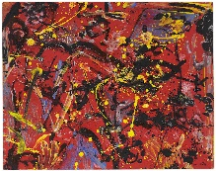 | Yayoi Kusama Piet Mondrian, Wassily Kandinsky  Yayoi Kusama, Piet Mondrian, Wassily Kandinsky, primary colours, bold, squares, rectangles, thick lines, thin lines, shapes, circles  Exploration of Yayoi Kusama, Piet Mondrian, Wassily Kandinsky through texts, videos, discussions and teacher demonstrations, children to recreate their artwork. | Joan Miro  Shapes, drawing, squiggles, thin lines, pen, pencils, colours, doodles, symbols.  Exploration of Joan Miro through texts, videos, discussions and teacher demonstrations, children to recreate their artwork. | Andy Goldsworthy Eric Carle  English, photographer, sculpture, nature, natural, leaves, sand, ice, stone, tissue paper, colours, caterpillar, animals, minibeasts.  Exploration of Andy Goldsworthy and Eric Carle through texts, videos, discussions and teacher demonstrations, children to recreate their artwork. | Vincent van Gogh  Sunflowers, museum, Dutch, oil painting, Starry night, yellow, observational, soft, muted, background.  Exploration of Vincent van Gogh through texts, videos, discussions and teacher demonstrations, children to recreate their artwork.  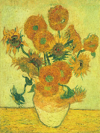 | Georgia O’Keeffe, Henri Matisse  Flowers, copy, colours, observe, shape, bright, bold, realistic, unusual, still life, French, American, paper collage, scissors.  Exploration of Georgia O’Keeffe and Henri Matisse through texts, videos, discussions and teacher demonstrations, children to recreate their artwork.
Development of Children’s Mark Making and Drawing  Intent  Vocabulary  Implementation | Learning how to grip a pencil and making marks through a range of shapes e.g. lines and circles. Children are giving meaning to marks they have made.  Grip, pinch and flick, tight, loose, hand, lines, circles, shapes, copy, explain  Mark making area, Workshop and creative areas, modelling how to use equipment safely. | (Skill) Observational drawings linked to children’s interests. Begin to understand how to use shapes to represent objects.  Observe, copy, look, notice, shape, colour, lines, represent.  Mark making area, Workshop and creative areas, modelling how to use equipment safely, Pumpkins, leaves on Creative table, modelling observational skills. | (Skill) Convey emotions in their pictures/ drawing e.g. happiness, sadness. Draw with increasing complexity and detail e.g. adding eyes, nose, mouth to pictures.  Emotion, feeling, detail, features, circles, shapes, lines, colour  Mark making area, Workshop and creative areas, modelling how to use equipment safely, Modelling adding finer details, using the work of Miro. | (Skill) Continue with the development with observational drawing linked to interests and artists.  Observe, copy, look, notice, shape, colour, lines, represent, flower, daffodil.  Mark making area, Workshop and creative areas, modelling how to use equipment safely, Modelling observational skills and the use of colour. | (Skill) Continue with the development of observational drawing linked to the theme. Continue to develop the accuracy and detail in their drawing.  Observe, copy, look, notice, shape, colour, lines, represent, flower, sunflower, Van Gogh.  Mark making area, Workshop and creative areas, modelling how to use equipment safely, Modelling observational skills, the use of colour and taking care and time. | (Skill) Children discussing their work and the details used on their illustrations and showing lots of detail on these.  Detail, explain, thick, thin, colour, observe, notice, like, dislike, reason.  Mark making area, Workshop and creative areas, modelling how to use equipment safely, Modelling observational skills, the use of colour, adding finer detail and explaining your art work, questioning children about their work.
Development of use of Colour  Intent  Vocabulary  Implementation | (Knowledge) Know the names of many colours and uses these in their work.  Colours, colour names, change, lighter, darker, mix, primary colour, secondary colours, light, dark.  Discussing colour names during play and discussions. | (Skill) Explore a range of colours and how colours can be changed e.g. colour mixing.  Colours, colour names, change, lighter, darker, mix, primary colour, secondary colours, light, dark.  Paints available to children, modelling mixing colours, prompting children to identify dark and light colours in play and discussions. | (Skill) Explore the colour work of the artists studied this term. Purposely choosing a colour when creating.  Wash background, water colour, water, paint, light, dark, bold, faint, Joan Miro, combine, mix.  Modelling making a wash background, discussing use of colour and shape and light and dark colours. | (Skill) Exploring the colour work of Andy Goldsworthy – Nature.  Colours, colour names, nature, outside, style, similar, Any Goldsworthy, leaves, grass, soil, mud.  Using a colour chart and paint chart outside to identify colours. | (Skill) Exploring how to change colours through colour mixing and how white and black can change a colour.  Colours, colour names, change, lighter, darker, mix, primary colour, secondary colours, light, dark, shades.  Exploring black and white and how it can change a colour, a range of colours available on the painting table for children to explore. | (Skill) Planning ahead on which colours they will use and giving a purpose and reason for the colours they’ve used.  Colours, colour names, change, lighter, darker, mix, primary colour, secondary colours, light, dark, purpose.  Creative area with paints set up for children to access and colouring pencils and crayons, a range of art work examples.
Development of the use of Paint  Intent  Vocabulary  Implementation | (Skill/Knowledge)  Exploring the painting area within the setting, using the area independently or with support and using techniques of Artists studied this term.  Paint, painting, colour, choice, splatter, flick, Jackson Pollock.  Creative area, workshop area, toothbrushes in provision, paintbrushes in provision, exploration of Jackson Pollock’s work, teacher modelling of work. | (Knowledge)  Knowing pictures do not need to use multiple colours. Working on choosing particular colours for the painting they are creating.  Paint, painting, colour, choice, Yves Klein  Creative area, workshop area, toothbrushes in provision, paintbrushes in provision, exploration of Yves Klein’s work, teacher modelling of work. | (Experience) Developing an understanding that there are different types of paint and that paint can be added to, to change its colour and consistency e.g. sand.  Paint, painting, colour, choice, type, poster, ready mix, acrylic, powder, water colour, sand, glitter. Creative area, workshop area, toothbrushes in provision, paintbrushes in provision, exploration of a range of media through modelling and then in provision. | (Skill) Children continuing to become more confident and independent when painting and using the skills and techniques they’ve been taught and seen through a range of artists.  Paint, painting, colour, choice, mix, new, primary and secondary  Creative area, workshop area, toothbrushes in provision, paintbrushes in provision, exploration of mixing paints to make new colours | (Experience) Continue to develop a wide range of experience with using paint on a small and large scale.  Explore using different brush types and noticing artists who also do this.  Paint, painting, colour, choice, surface, paper, card, brushes, thick, thin, difference. Creative area, workshop area, toothbrushes in provision, paintbrushes in provision, exploration of a range of media. | (Skill) Children knowing what they want to paint and why using their imagination and feelings – they can explain why they’ve chosen their materials and how they may do it differently next time.  Paint, painting, colour, choice, inspiration, feeling, emotion, imagination, observation, evaluate, like, dislike, change, similar, different, improve, better.  Creative area, workshop area, toothbrushes in provision, paintbrushes in provision, exploration of a range of media.
Development of Printing  Intent  Vocabulary  Implementation | (Experience/Skill) Children exploring printing through access to paint to print with their hands and fingers and knowing they are allowed to do this.  Print, paint, choice, hands, feet, fingers, smudge, clear print.  Printing materials explored together as a class and on offer in provision. | (Skill) Children being introduced to larger printing tools to be used indoors and outdoors.  Print, paint, choice, smudge, clear print, sponge, rollers, shapes, Mondrian, primary colours, Kandinsky.  Printing materials explored together as a class and on offer in provision. Mondrian’s work explored together as a class. | (Skill) Children exploring printing tools – both natural and man made e.g. leaves and ear buds.  Print, paint, choice, smudge, clear print, objects, leaves, pine cones, flowers.  Printing materials explored together as a class and on offer in provision. Exploration of natural materials – bring in from outside to print. | (Skill) Children exploring how patterns can be printed.  Print, paint, choice, smudge, clear print, objects, patterns, environment, world, nature.  Printing materials explored together as a class and on offer in provision. Exploration of natural materials – bring in from outside to print. Teaching of repeating patterns. | (Skill) Children printing using a range of media, independently printing patters including symmetrical patterns.  Print, paint, choice, smudge, clear print, symmetry, the same, pattern, butterfly, shape, colour.  Exploration of symmetry using a mirror, a line to repeat on each side, symmetrical butterfly printing explored and then left in provision. | (Skill) Children printing pictures using the skills and knowledge learnt throughout the year.  Print, paint, choice, smudge, clear print, ideas, explain, reason, why.  Printing materials in provision for children to use independently.
Development of the use of Textiles and Materials  Intent  Vocabulary  Implementation | (Understanding) Children exploring the available materials within their new setting.  Materials, textures, fabric, play-dough, natural, soft, hard, bendy, rough, smooth.  Exploration of a range of materials and their functions, creative areas. | (Skill) Children being shown how to use junk modelling materials to build and construct models.  Materials, textures, junk, modelling, build, tower, structure, higher, lower, taller, shorter, stronger, sturdy, glue, sellotape.  Junk modelling materials available in class, different functions of glue explored with class. | (Knowledge) Exploring different types of materials and what their properties and uses are.  Materials, textures, clothing, winter, warm, thick, soft, insulate, hot, cold, wool, cotton.  Exploration of a range of materials and their functions, materials available in creative areas, winter clothing available outside to be explored with outdoors. | (Skill) Learning what a collage is and how we can collage using different materials and which ones work best and look most effective.  Materials, textures, collage, Eric Carle, play dough, flour,  Collage exploration, collage materials available to class. | (Skill) Children being taught how to weave, looking at man-made weaving materials as well as natural weaving materials e.g. leaves with holes and dandelions.  Materials, textures, weaving, instructions, in and out, natural, manmade, pattern.  Weaving demonstrated to the class, weaving materials available in provision, | (Skill) Children continuing to learn to weave and exploring weaving.  Materials, textures, natural, leaves, thread, , weaving, in and out.  Modelling and instructions on how to weave with links to how to sew.
Development of modelling and 3D work  Intent  Vocabulary  Implementation | (Understanding) Children being shown the loose parts in the class and being shown how they can be used.  Transient art, loose parts, moveable, creation, colour, shape, patterns.  Exploration of loose parts, modelling of how they can be used, images of ideas. | (Skill) Children being shown how to use simple joins when using different materials to create  Joins, materials, 3D, 3D work, sellotape, masking tape, sellotape, glue stick, stronger, hold.  Exploration with the class of different ways to join materials and which is the best method for which material. | (Skill) Children making models and creations for their own pleasure and for events and celebrations.  Celebrate, bunting, paper chains, joins, glue, paper, card.  Reading stories about celebrations, exploring pre-made paper chains, exploring the process of paper chains, making cards and other decorations. | (Skill/Knowledge)  Children exploring how natural resources can be manipulated to make 3d sculptures.  Natural art, nature, patterns, outdoors, Andy Goldsworthy, style, copy, similar.  Going outside to see living art and nature, creating repeating patterns with nature, building with natural objects outdoors. | (Skill) Children specifically using certain materials for their own ideas.  Props, puppets, folding, technique, fan, book, material, feather headdress.  Exploration of puppets, discussing and modelling ways to make puppets, looking at folding techniques together – modelling and giving children the materials to access, giving children a range of mateirals to access from. | (Skill) Children having the skills and understanding to use a range of tools and materials to join, assemble and build models and 3D work.  Tools, techniques, join, assemble, materials, glue, folds, sellotape, adapt, change, review, explain.  A range of tools, materials, textiles available for children to access using the taught methods shown to them across the year.
Development of Cutting skills  Intent  Vocabulary  Implementation | (Skill) Children being shown how to scissors to make snips safely.  Tools, cutting, scissors, care, safety, equipment, snips, small snips, large snips, paper.  Demonstration and discussions around scissor safety, modelling the use of scissors – open and close to make small snips in a repeated process, scissors in provision. | (Skill) Children building confidence and skill in using scissors.  Tools, cutting, scissors, care, safety, equipment, snips, small snips, large snips, paper, straight line, copy, follow.  Demonstration and discussions around scissor safety, modelling the use of scissors – open and close to make small snips in a repeated process to follow a line, scissors in provision. | (Skill) Children building confidence and skill in using scissors.  Tools, cutting, scissors, care, safety, equipment, snips, small snips, large snips, paper, curved lines, copy, follow, trace.  Demonstration and discussions around scissor safety, modelling the use of scissors – open and close to make small snips in a repeated process while moving the paper around to follow a curved line, scissors in provision. | (Skill) Children building confidence and skill in using scissors  Tools, cutting, scissors, care, safety, equipment, snips, small snips, large snips, paper, shapes, lines, copy.  Scissors in provision, a variety of shapes for children to cut, materials and pictures available for children to cut freely. | (Skill) Children using scissors independently and safely.  Tools, cutting, scissors, care, safety, equipment, snips, small snips, large snips, paper, independence, lines, follow.  Scissors in provision, a variety of shapes for children to cut, materials and pictures available for children to cut freely. | (Skill) Children using scissors to support them in their creations.  Tools, cutting, scissors, care, safety, equipment, snips, small snips, large snips, paper, purpose, independence.  Scissors in provision, a variety of shapes for children to cut, materials and pictures available for children to cut freely.
Understanding the World  Past and Present  Intent  Vocabulary  Implementation | Children talk about members of their family and the relationship to them e.g. Mum, Dad; and begin to compare their family to others.  Family, relationships, Mum, Dad, sister, brother, grandma, grandad, friends.  Children joining in with discussions and stories about family. Children focusing on work based on ‘all about me’ and their family and friends.  Compare their family to others, discussing the similarities and differences. | Children use the language of time when talking about past and present events in their own lives and in the lives of others. Children to think about Christmas in the past, including their own and before they were born.  Last week, yesterday, a long time ago, last year, before I was born.  Discussions around past and present – events such as celebrations, Remembrance Day (war). | Children visually represent their own day on a simple timeline.  Timeline, day, week, first, last, them, next, days of the week – names.  Children learning about the days of the week in and out of Maths lessons. Children having a visual timetable. Children completing practical activities visually representation their week. | Children talk about and understand changes in their own lifetime and what happens when they get older.  Changes, baby, toddler, child, teenager, adult, elderly, ages.  Learning about life cycles of animals, learning about how we grow and change as people. | Children recount an event that has happened.  Event, special, what happened, then, next.  Discussions around events we have had at school such as Acorn Farm visit and trip to Stanley Park. | Children can order experiences that have happened to them and in stories they have read.  First, then, next, after that, finally, story.  Adults prompting children to order experiences and stories verbally or in a written method.
Development of Enquiry  Intent  Vocabulary  Implementation | Children know that you can find out information from different sources  Information, books, videos, search, internet,  Adults modelling how to find information using a range of sources. Adults giving children access to books to find information. | Children find out about key historical events and why and how we celebrate today? Remembrance Day, Christmas Day, Diwali.  History, past, celebrations, festivals.  Adults providing opportunities to explore a range of festivals and celebrations. | Children make observations about different locations and places. They recognise, know, and describe features. Understand some changes in the natural world around them, including the seasons.  Technology, search, internet, Antarctica, desert, changes, water, ice, seasons.  Adults providing images and books in the provision to enable children to make observations about different locations. | Children describe images of familiar situations in the past when looking and contrast images or stories. Children are taught about growth and change. Images, pictures, past, present, same, different, grow, change.  Children exploring images from the past through stories. Adults providing activities and inputs based on changing and growing. Reading stories such as ‘Peepo’. Adults to prompt children to discuss change when looking at their own baby photographs. | Children talk about roles people have in society (both in the present and past). Children understand he need for these roles.  Key worker, job, help, helpful, community, police, fire service, doctor, dentist.  Adults providing experiences, activities and inputs in the people in society in the present and in the past. Children comparing the past and present. | Children are confident in comparing and contrasting the past and present and can describe and ask questions about old and new. They notice similarities and differences independently and talk about these.  Images, pictures, past, present, change, different, people, places, time, compare, comparison, same.  Children provided with images to compare with past and present. Discussions around past and present.
Development of the understanding of ‘Respect’  Intent  Vocabulary  Implementation | Children respect special things in their own lives. Special, teddy, photo, people, toy.  Children taught about respect, children taught about respecting special things and what this might mean to different people. | Children recognise that people have different beliefs and celebrate special times in different ways. Children recognise some environments that are different to the one in which they live.  Belief, religion, special, special book, celebrate, celebration, different, same, cold, landscape related vocabulary.  Children taught about respect, children taught about different beliefs and special times for different people. | Children understand what curiosity is and importance of asking questions. Children find out about other countries and people through non-fiction texts, stories, celebrations.  Questions, why, country, community, where I live, story, celebrations.  Children taught about respect, children taught about curiosity, asking questions and why we need to learn. | Children understand what curiosity is and importance of asking questions. Children find out about other countries and people through non-fiction texts, stories, visitors, celebrations including Easter.  Questions, why, country, community, where I live, story, visitor, celebrations.  Children taught about respect, children taught about curiosity, asking questions and why we need to learn. | Children know that different places are special to different people.  Special, places of worship, Eid, Mosque, churches, map, park, shops etc.  Children taught about respect and how we can respect special places. | Children can compare and contrast different places. Children show respect to one another and to animals.  Same, different, similar, features, environment, hot, cold, care, look after, vets, food, water.  Children taught about respect and caring for animals and pets and the planet.
Development of Mapping skills  Intent  Vocabulary  Implementation | Children can draw a simple map and listen to stories with maps. Children recognise some common signs.  Maps, mapping, environment, features, classroom map, local area map, signs, logos.  Exploring maps as a class, reading stories with maps, creating a classroom map, exploring logos and signs as a class. | Children use positional language.  Maps, mapping, environment, bee-bot, left, right, under, beside, on top.  Modelling how to use a bee-bot and positional language. | Children can use positional language and extend this to using a BeeBots or instructing a friend to move. Children recognise some environments are different to the one in which they live.  Maps, mapping, environment, bee-bot, left, right, under, beside, on top, up, down, same, different, landscape.  Modelling how to use a bee-bot and positional language. Adults setting up a small world track for children to use the Bee-bots with. Looking at maps of the local area and maps of Antarctica. | Children can confidently programme a BeeBot. Children can talk about technology and how it can help us direct ourselves – Google Maps.  Maps, mapping, environment, bee-bot, left, right, under, beside, on top, google maps.  Modelling how to use a bee-bot and positional language. Children having the Bee-bot grid maps to use. Children being shown what Google maps is and its uses. | Children can draw information from a simple map and identify landmarks of our local area walk.  Maps, mapping, environment, features, landmarks, local area.  Children going on a walk together around the local area. To identify landmarks and create a map. | Children can create own maps using grid paper and symbols (x marks the spot treasure maps)  Maps, mapping, environment, features, landmarks, local area, x marks the spot, treasure.  Children using the available materials to create their own maps as modelled by the adults in school.
Development of Scientific skills and Knowledge  Intent  Vocabulary  Implementation | Children learn about the seasons and know it is Autumn. Children talk about the seasons and have some understanding about the changes that happen in the world. Autumn, day, dark, light, Winter, night, season, Moon, Sun, lighter, darker, shadow  Exploring seasons through stories, videos, books. Making a record of the seasons or weather such as a weather chart, seasons booklet etc. | Children identify and name a variety of everyday materials, including wood, plastic, glass, metal, water, and paper. Children are beginning to understand what ‘re-cycle’ means and why we should do it.  Material, wood, plastic, glass, metal, paper, recyclable, hard, soft, rough, smooth, shiny  Exploring the materials as a class – naming them. Exploring the properties of these materials through continuous provision and whole class inputs. Reading and investigating what recycling means and how we can recycle. | Children can describe an animal using some scientific vocabulary. Children have an understanding of some animal habitats and can describe them and who lives in them.  Polar animals (Penguin, Artic fox, Orca, Elephant seal, Polar Bear, Snowy Owl), frozen, camouflaged, survival.  Exploring animals and labelling them. Exploring what animals need to survive and how that changes depending on the environment they are in. | Discussions around human lifecycles and how we grow and change – children understanding how they have grown and how they will continue to grow. Looking at how they look and people older than them look – what is the same and what is different. Naming body parts and how to keep ourselves healthy.  Hygiene, healthy, nonhealthy, grow, change, germs, 5 senses, teeth brushing, dentist, face, hair, leg, human, knee, arm, elbow, back, head, toes, ear, hands, eye, fingers, mouth, nose, parent, baby, child, adult, grandparent  Continue with the work on seasons and weather from the Autumn term. Discussions and inputs around growth and changes in the human body. Learning about healthy eating and how the body works. | Children can name parts of a plant and what it needs to grow as part of the current topic. Children can grow their own plants and look after them. Children observe the plants and trees around them and how they change. Children are developing a good understanding of a lifecycle as part of the topic.  Tulip, daffodil, bluebells, crocuses, snowdrops, dandelions, buttercups, daisy Plant, stem, leaf, roots, bulb, shoot, seed, growth flower, trunk, branches. life cycle, egg, caterpillar, chrysalis, cocoon, butterfly, water, food, air  Exploring plants and the parts of the plants, looking at lifecycles of plants, identifying plants. | Children are confident at naming a range of animals and where they live (habitat) and can sort some animals into the country they live in. Children care for and look after animals and encourage others to do son. Children can compare animals and observe their changes (Lifecycles)  Pond, garden, woodland, seaside, habitat, wild, wildlife, native, woodland, birds, (owl, duck), insects/bugs/ minibeasts (lacewing, ladybird, woodlouse, bee, wasp, spider, tarantula, earthworm, snail, millipede, butterfly, caterpillar, microhabitats,  Identifying, observing and exploring British animals – in person, through books, videos etc.
Development of Imagination and Roleplay  Intent  Vocabulary  Implementation | Children exploring the roleplaying area/s within the setting and joining in with familiar pretend play. Children exploring and using the resources to create props or bring in and use materials to support play. Children building and developing storylines in both the small world area and role-playing in the setting.  Join in, pretend, roleplay, home corner, mums, dads, baby, small world, people, vehicles, cars, recreate, represent, shops, schools.  Updated roleplay area, creative area with resource for children to create and build from, modelling of how to use the role play area and creative area, stories read as a class, small world area available to children. |  | Children using the stories they know and have heard in school to roleplay them Children extending their roleplay with more imaginary storylines. Children continuing to use the props available in school and ones they have made themselves.  Join in, pretend, roleplay, retell, stories, acting out, puppets, toys, small world, masks, home corner, conversations, taking on a role, pretending.  Updated roleplay area, creative area with resource for children to create and build from, modelling of how to use the role play area and creative area, stories read as a class, small world area available to children. |  | Children continuing to extend and develop the storylines they are role playing in school. Children will independently sing, dance, roleplay, create artwork and may show a passion for one or more ways to express their imagination.  Join in, pretend, roleplay, retell, stories, converse, conversation, represent, real life, imagination, celebrations, daily life, shopping, school.  Updated roleplay area, creative area with resource for children to create and build from, modelling of how to use the role play area and creative area, stories read as a class, small world area available to children, singing songs, rhymes and doing guided roleplaying activities together as guided groups or a whole class.

