Curriculum Overview | Year 3
 | Autumn Term |  | Spring Term |  | Summer Term
English Book | The Iron Man | The Fox | The Rhythm of the Rain | The Visible Sounds | Egyptology | Into the Forest
Maths | Place Value/Number / Multiplication & Division |  | Number/Measure/Fractions |  | Fractions/Money/Time/Shape/ Statistics
Science | Plants | Rocks | Light | Animals Including Humans | Forces and magnets | Animals including humans (The Bee  Project )
History | Ancient Egypt | Cradles of  Civilisation | Indus Valley | Persia and  Greece | Ancient  Greece | Alexander  the Great
Geography | Rivers | Mountains | Settlements | Agriculture | Volcanoes | Climate
Computing | Altering Media |  | Publishing Online Content  Emails |  | Introduction to Scratch
Physical Education | Fundamentals | Ball Skills | Gymnastics | Dance | Tennis | Athletics
Music | Across the year we will be working with Resonate to deliver Music lessons were the following will be taught:  Exploring structure(RnB)  Playing skills (Flute / Clarinet)  Reggae  Songs that tell stories  Bringing us together-Disco  Rhythm/Tempo/Dynamics

 |  |  | Music from around the  world |  | Classical music  Music history
Design and  Technology | Mechanisms-Pop Up |  | Food |  | Structures
Art and Design | Drawing |  | Painting and Printing |  | Textile and collage
Spanish | About me/ Numbers/ Colours/ Body  Parts | Objects/ Instructions/ Number/  Colours | Days and Months/ Numbers/  Birthday | Animals/ Descriptions/ Numbers | Sport/ Dear Zoo Story/ Numbers | Fruits/ Handa’s Surprise/  Numbers
PSHE | Being me in my  world | Celebrating  Difference | Relationships | Healthy Me | Dreams and  Goals | Changing me
Enrichment/Visits/Vi sitors/ | World Museum Water Safety (RNLI) |  | Concert-Royal Philharmonic Reggae Musician |  | Chester Zoo  Additional work on Handa’s  surprise
Cultural Enrichment | 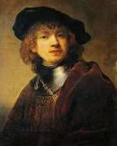  Explore and appraise famous drawings by Rembrandt. |  | .  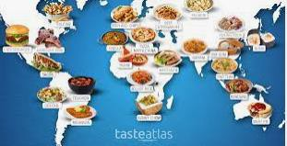 |  | Structure- Iconic architectural designs and designers-buildings to sculptures.

 |  | Food Tasting afternoon- children to experience tasting a variety of foods | 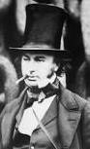  Isambard Renzo Piano(shard)  Kingdom  Brunel

