 | Year One
 | Autumn Term |  | Spring Term |  | Summer Term
English Book | Old Bear. | Rapunzel. | Hermelin. | The Wild things. | The Secret of Black Rock. | The Last Wolf.
Maths | Numbers to 10.  Part-whole within 10.  Addition within 10.  Subtraction within 10.  2D and 3D shapes. Consolidation. |  | Numbers to 20.  Addition and Subtraction within 20.  Numbers to 50.  Introducing length and height.  Introducing mass and capacity.  Consolidation. |  | Multiplication and Division.  Fractions.  Position and Direction.  Numbers to 100.  Money.  Time.
Science | Animals including humans. |  | Everyday  materials. | Plants. | Seasonal Changes.
History | How am I making History? |  | How have toys changed? |  | How have explorers changed the world?
Geography | What is it like here? |  | What is the weather like in the UK? |  | What is it like in Shanghai?
Computing | Basic Computing Skills | Presenting Information | iAlgorithim | iProgramme Bluebots | iData | iWrite

Physical Education | Fundamentals | Ball skills | Sending and Receiving | Gymnastics | Dance | Athletics
Music | My Musical Heartbeat  Dance Sing and Play! |  | Exploring sounds  Learning to Listen |  | Having fun with improvisation  Let’s Perform together!
Design and Technology | Mechanism’s. |  | Cooking. |  | Textiles. (Puppets)
Art and Design | Drawing |  | Textiles/collage |  | Painting/printing
PSHE | Being me in the  World | Celebrating  Difference | Relationships | Healthy Me | Dreams and  Goals | Changing  Me
Enrichment/Visits/Visitors/ | Visit of the local area. |  | Toy Workshop. |  | Martin Mere.
Cultural Enrichment | 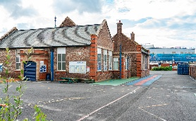  Then and now of our local area. The history of our school. |  | 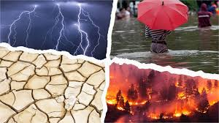  Learning about weather in different cultures including extreme weathers. |  | 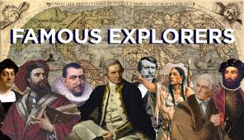  Learning about explorers who changed history.

