Gwladys Street Community Primary and Nursery School Long Term Plan

Geography

Key Stage 1
 | Autumn | Spring | Summer
Year 1 | What is it like here?  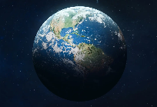  Children will locate features on an aerial photograph of our school. They will know the name of the country and city in which we live. They will make a map of their classroom with key features, using objects to represent the distance and direction of features in the classroom. They will recognise features in the school grounds using a map. | What is the weather like in the UK?  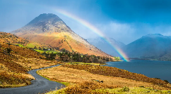  Children learn to identify and locate the four UK countries, recognise their own country and describe locations using basic compass directions. They also measure different types of weather, using symbols used in weather forecasts, describe seasonal changes and suggest appropriate clothing and activities for each season. | What is it like to live in Shanghai?  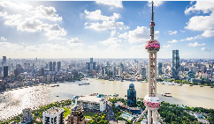  Children will be able to give examples of human and physical features. They will use an atlas to locate the UK, China, Europe and Asia on a world map. Children will compare Shanghai to Liverpool.
Year 2 | Would you prefer to live in a hot or cold place?  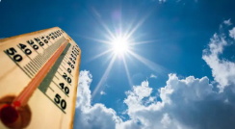  Children will learn and locate the seven continents on a world map, along with the North and South Poles. They will recognise the features of hot and cold places and will locate some countries with hot or cold climates on a world map. | Why is our world wonderful?  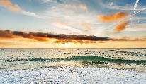  This unit will give the children knowledge to explain the difference between oceans and seas. Children will identify and locate characteristics of the UK on a map and will name and locate the five oceans on a world map. | What is it like to live by the coast?  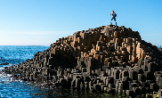  In this unit children will name and locate the seas and oceans surrounding the UK in an atlas and be able to label these on a map of the UK. This unit will help children define what the coast is, and they will be able to locate coasts in the UK and name some of the physical features of coasts.

Key Stage 2

 | Autumn 1 | Autumn 2 | Spring 1 | Spring 2 | Summer 1 | Summer 2
Year 3 | Rivers  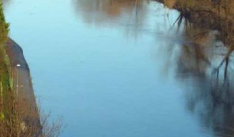  The River Indus - its source, course, human interactions with environment. How rivers get their water - the source, springs, the water cycle. How do rivers shape the land? The river’s load. Flooding: River Severn (Wildlife in the River Severn).  Geographical skills: Using photographs | Mountains  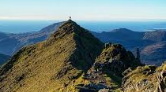  Highest mountain in each of the four countries of the UK.  Mountain ranges and mountainous regions: Brecon Beacons, Highlands, Lake District, Snowdonia, Pennines, Yorkshire Dales.  Why do people live on mountains?  Relationship between mountains and weather  Relationship between mountains and people.  Geographical skills: Describing location using 4-point compass | Settlements  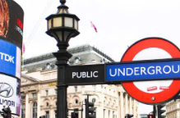  Settlement types, hamlet, village, town, city etc; land use, settlements by rivers. Major cities in the UK – locational overview. London as a conurbation and London boroughs.  Two cities: Cardiff and London, including economy & transport. How do people move about in Cardiff?  How do people move about in London?  Patterns of settlement in Cardiff and London. | Agriculture  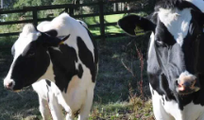  Arable farming, pastoral farming, mixed farming, how farming changes the landscape.  How the food we eat affects farming (seasonal food, local food, pesticides, organic food, vegetarian and plant-based diets that do not use animals.  Sheep farming in Wales – Snowdonia.  Locational knowledge revisited: Wales, Snowdonia, Gloucestershire. New locational knowledge: Sussex  Geographical theme: links between food consumption patterns and farming; issues arising e.g. local sourcing.  Geographical skills: Optional local fieldwork on local shops – their sourcing, economic and ethical considerations. | Volcanoes  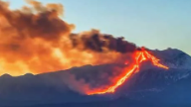  Structure and composition of the earth.  How and why volcanoes erupt  Types of volcanoes Active, dormant and extinct volcanoes  Why people visit volcanoes (work, tourism, farming, science)  Geographical skills: Using diagrams, describing distribution. | 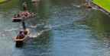  Climate and biomes  Continent of Europe  Climate zones - first mention of Equator, Arctic, Antarctic and the North/South poles.  Climate and relationship with oceans.  Climate and biomes within climates  Geographical skills: World map and key lines of latitude.
Year 4 | The River Mersey  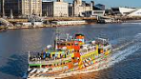  Water as a vital resource for transporting goods like salt and cotton, reflecting themes from ancient civilisations.  How The River Mersey was reshaped by humas to drive trade and industry.  Geographical skills: Extending use of maps and photographs | Population  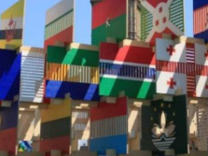  Characteristics of population including distribution and diversity. Migration.  Depth focus: multicultural London. Depth focus: multicultural Cardiff.  Welsh language and culture, effect of changing demographics  Welsh or British? Idea of national identity.  Geographical skills: Thematic maps and using census data | 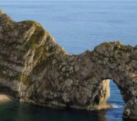  Costal process and landforms  Diversity in the UK coastline.  Processes of erosion, transportation & deposition.  Coastal landforms including beaches, headlands and bays.  Overview of Jurassic coast, including significance of its rocks, fossils and landforms.  Coastal habitats using contrasting examples, including coasts of the Indian Ocean.  Depth focus: West Wales coast | Tourism Depth  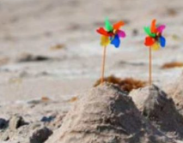  Llandudno, Wales - a seaside town (link back to coastal processes in previous unit).  Types of tourism (e.g. visiting friends and family activity holidays). Skiing holidays in the Alps.  The growth of tourism in the UK and overseas. Sunshine holidays in Spain.  Advantages and disadvantages of tourism.  Sustainable tourism.  Geographical skills: Interpreting climate data. | Earthquakes  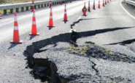  Depth focus: The Christchurch earthquake, New Zealand.  Causes of earthquakes: tectonic plates, fault lines Depth focus: California & San Andreas fault, Indian Ocean tsunami  Effects of earthquakes How humans live in earthquake zones and adapt their settlements (e.g. Japan)  Revisits knowledge on volcanoes from Year 4 Spring 1.  Geographical skills: Thematic maps | Deserts  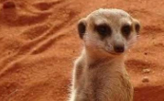  Distribution and climate of deserts  Depth focus: The Sahara Desert How deserts are formed, variety of landscapes.  Plants and animals in deserts How humans live and adapt in deserts.  Depth focus: The Patagonian Desert  Geographical skills: Interpreting thematic maps and satellite photographs
Year 5 | 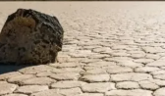  Why is California so thirsty?  Water as a resource  Depth focus on California (region in North America), continuing natural resources theme (revisit water cycle from Year 3).  Water resources in California Farming - intensive farming, growing almonds California aqueduct – providing water.  The future of water supply in California.  Geographical skills: Interpreting a range of thematic maps | Oceans  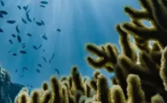  Locational framework – world oceans, seas in Europe.  Oceans and trade, oceans and climate, major currents.  Oceans and the land masses we’ve studied in depth – the Atlantic and West Wales.  The Pacific and South America.  Oceans and climate change, the human impact on oceans.  Geographical skills: Interpreting world and thematic maps | Migration  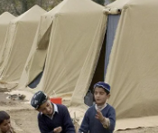  Real migration stories in people’s own words, from Northern Ireland to Liverpool and from Turkey to London.  Why do people migrate?  Push and pull factors revisited (from Year 5 Autumn 1) and extended in new contexts.  Refugees, persecution, asylum, asylum seekers; challenges for refugees.  How does migration change places?  London, Shetland Islands, Cambridgeshire Migration and identity: examples from diverse settings showing complexity of identity, dual nationalities, multiple identities, and the role of place in identity.  Understanding place in relation to scale.  Geographical skills: Asking questions, eight-point compass | 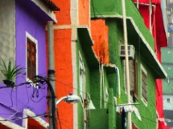  North and South America  Human and physical characteristics of North and South America, including population distribution and climate.  Megacities including Lima and depth focus on Brazil’s megacities.  Urban-rural migration in Brazil, including informal settlements, like favelas.  Challenge stereotypes often held of the favelas.  Geographical skills: 4-figure references, thematic maps | The Amazon  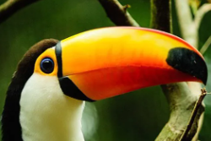  A depth focus on the Amazon as a region in South America, including conversations between UK children and children from the Bolivian Amazon.  The Amazon river – course and characteristics.  The Amazon ecosystem – vegetation, animals and food chains. Ecosystem processes. Causes and effects of deforestation.  Futures for the Amazon rainforest.  Geographical skills: Flow diagrams, interpreting satellite photos. | 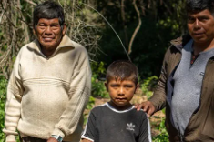  Interconnected Amazon  Farming in the Amazon: depth focus on the Bolivian Amazon (starting with the same community as in Summer 1).  The journey of soy produced in Bolivia.  Primary, secondary, and tertiary industry.  International trade.  Effects of changes in trade.  Trans-national companies.  Environmental connections, carbon cycle, impacts of deforestation. Social connections, globalisation.  Geographical skills: Interpreting and drawing bar graphs, simple enquiry process, questionnaire
Year 6 | 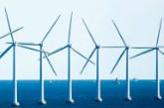  Energy and Climate Change  How people use energy Types of energy.  Renewable and non-renewable energy sources.  The greenhouse effect. Enhanced greenhouse effect – causes (including energy use and farming).  Climate change and its effects (building on earlier work on oceans and interconnection) examples from Antarctica, Great Barrier Reef, Pacific Islands, South Asia, UK.  How can we respond?  Geographical skills focus: Interpreting line graphs | Ethiopia  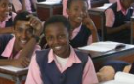  Where is Ethiopia?  Location in Africa (introduction only as this continent is a focus in KS3)  What is Ethiopia like?  Climate, landscape (including Great Rift Valley), population, biomes, major cities, rural life.  Sustainable futures – challenges faced due to climate change, UN sustainable development goals, depth focus on one project.  Geographical skills focus: Population pyramids, longitude and time zones | 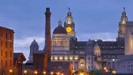  Changing Liverpool  This unit reviews and extends knowledge of cities in the UK, focusing on past, present and future changes.  Where is Liverpool? How has it changed in the past? Growth and development of the city, industry, migration, deindustrialisation, redevelopment How is it changing now?  What might Liverpool be like in the future?  Possible, probable, and preferable futures.  Geographical skills: Interpretation and presentation of data | Jamaica  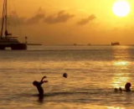  An in-depth place focus to complement other regions studied in North and South America (California, the Amazon) and to link with themes in History.  Where is Jamaica?  Reinforcing knowledge gained about the world, including time zones, and developing understanding of the Caribbean.  What is Jamaica like?  Climate, landscape, population history, migration, ocean biomes.  Tourist industry.  Sustainable futures – environmental challenges faced due to tourism, ways forward | Fieldwork  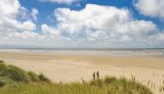  How do geographers find out about a place?  Ordnance survey maps, revision of symbols, 8-point compass and four-figure grid references, extending to 6-figure grid references.  Interpreting a range of maps and data, bringing together skills from all topics in KS2 (e.g. atlases, thematic maps, digital technologies)  What questions can we ask about the local area?  Setting up a fieldwork enquiry and going through the stages of the enquiry process (asking questions, collecting data, analysing data, presenting findings).  Geographical skills: Ordnance survey maps, 6-figure grid references, enquiry process, local-area fieldwork  Disciplinary focus: How geographers investigate a place | Fieldwork  How do geographers find out about a place?  Ordnance survey maps, revision of symbols, 8-point compass and four-figure grid references, extending to 6-figure grid references.  Interpreting a range of maps and data, bringing together skills from all topics in KS2 (e.g. atlases, thematic maps, digital technologies)  What questions can we ask about the local area?  Setting up a fieldwork enquiry and going through the stages of the enquiry process (asking questions, collecting data, analysing data, presenting findings).  Geographical skills: Ordnance survey maps, 6-figure grid references, enquiry process, local-area fieldwork  Disciplinary focus: How geographers investigate a place

