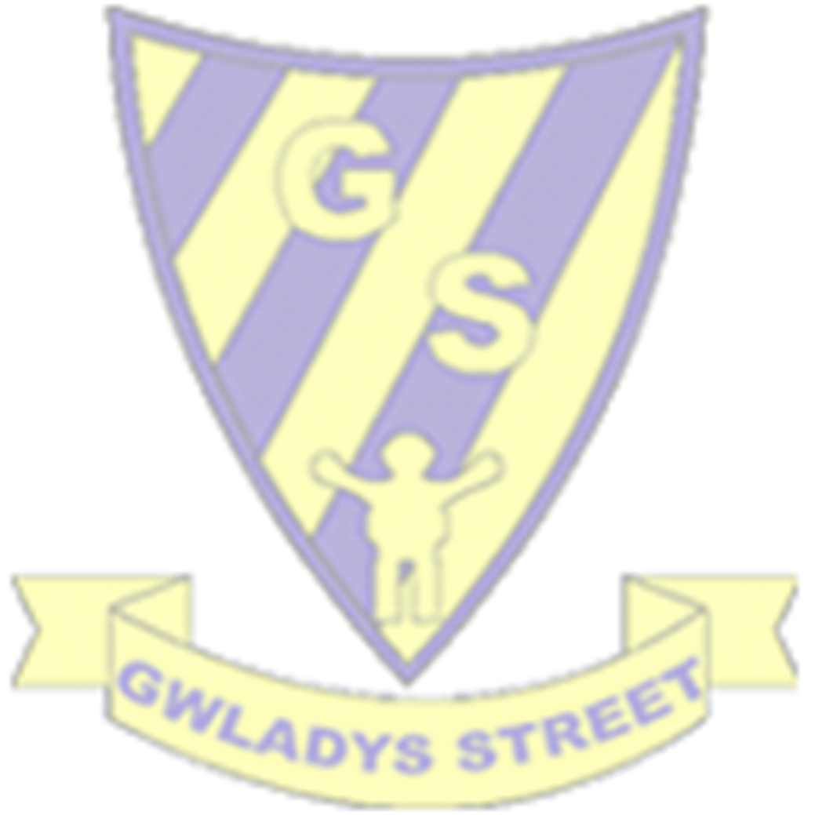
ART Progression of Skills and Knowledge
Key to understanding this document: black = National Curriculum objectives Red = Knowledge/Skills to be taught
Area of Learning | EYFS | Year 1 | Year 2 | Year 3 | Year 4 | Year 5 | Year 6
To produce creative work, exploring their ideas and recording their experiences. KS1 pupils should be taught to use a range of materials creatively to design and make products | 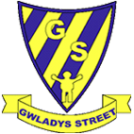  Exploring and using media and materials – children develop their own ideas through selecting and using materials and working on processes that interest them. Through their explorations, they find out and make decisions about how media and materials can be combined and changed. Being imaginative – children talk about the ideas and processes, which have led them to made designs, images or products. They can talk about features of their own and others’ work, recognising the differences between them and the strengths of others. | Explain what they  and others have  done.  What feelings does  it bring?  What might they  change?  Use a sketchbook  to collect ideas.  Ask and answer  questions about  starting points,  artists etc. | Experiment with  tools and surfaces  – oil pastels,  chalks, pencil,  colouring pencils -use a sketch book  on the playground,  fabrics, pastel  paper and wood  (Look at texture  and pattern)  Draw lines from  observations  Draw the gaps  (Draw shapes in  between objects) | To create sketch books to record their observation and use them to review and revisit ideas. Compare their work to others, methods, techniques, colours etc. Adapt their work after discussion. Use a sketchbook to collect ideas, develop ideas and annotate. Record from observations and their own imagination. | To create sketch books to record their observation and use them to review and revisit ideas. Compare ideas, methods and approaches used by themselves and others. Discuss how they feel about their own and others work. What might they change? Adapt work accordingly. Use a sketchbook to record observations and other visual information from different sources. Annotate ideas. Question, discuss and make observations about starting points/artists and artworks. What can they magpie for their own work? | To create sketch books to record their observation and use them to review and revisit ideas. Compare ideas, methods and approaches used by themselves and others. Discuss how they feel about their own and others work. What might they change? Adapt work accordingly. Use a sketchbook to record observations and other visual information from different sources. Annotate ideas. Question, discuss and make observations about starting points/artists and artworks. What can they magpie for their own work? | To create sketch books to record their observation and use them to review and revisit ideas. Compare ideas, methods and approaches used by themselves and others. Discuss how they feel about their own and others work. What might they change? Describe how they may change their work and why. Adapt work accordingly. Then discuss how they could change it further. Use a sketchbook to record close observations and other visual information from different sources. Annotate ideas. Question, discuss and make observations about starting points/artists and artworks. What can they magpie for their own work?
DRAWING KS1 pupils should be taught to use drawing to develop and share their ideas, experiences and imagination. KS1 pupils should be taught todevelop a wide range of art and design techniques in using colour, pattern, texture, line, shape, form and space. KS2 Pupils should be taught to improve their mastery of art and design techniques, including drawing with a range of materials. | Use a variety of  tools to mark make  – pencils, paint,  sticks, chalk,  water.  Draw into sand,  liquids, onto the  ground using  liquids and tools. | Use a variety of drawing tools – crayon, chalk, pencil, felt tips, poster paint. Draw light and dark lines (tone) Create rubbings (texture) Observe and draw shapes. Observe and draw patterns. | Experiment with tools and surfaces – oil pastels, chalks, pencil, colouring pencils, poster paint - on the playground, fabrics, pastel paper and wood (look at texture and pattern) Draw lines from observations Draw the gaps ( draw shapes in between objects) | Experiment with  different grades of  pencil, cross  hatching, blending  Use different  grades of pencil to  apply tone to  drawings  Make marks using  different drawing  implements – oil  pastels, charcoal  Create textures  with different  drawing  implements,  pencil, oil pastels,  charcoal  Use pencil,  charcoal and oil  pastels to draw  different form and  shape | make marks and  lines with a wide  range of drawing  implements, chalk  pastels, pencils,  fine liners, felt tips,  paint  apply and use  simple pattern and  texture to a  drawing  show an  awareness of  objects have a  third dimension | Use different  media to make  marks and lines in  dry media – digital  mark making,  pencil, charcoal, oil  pastels  Explore colour  mixing and  blending with  coloured pencils  Apply the effect of  light on objects  from different  directions  Begin to use  perspective in  work using a single  foci point and  horizon | Experiment with  wet media to make  marks, lines,  patterns, textures  and shapes – ink,  paint, watercolour  pencils  Produce accurate  drawings from  observation and  use tonal contrast  in drawings  Use mixed media  in artworks using a  combination of  areas taught –  print, ink, paint,  fabric, collage etc –  use pattern and  texture  Develop an  awareness of  composition, scale  and proportion,  foreground,  middle ground and  background.  Scale up and down  images.
COLOUR KS1 pupils should be taught to use painting to develp their ideas, experiences and imagination. KS1 pupils should be taught todevelop a wide range of art and design techniques in using colour, pattern, texture, line, shape, form and space. KS2 Pupils should be taught to improve their mastery of art and design techniques, including painting with a range of materials. | Experiment with  painting and  colour mixing using  powder paints,  poster paints and  water colours.  Experiment with  crayons, chalks  and oil pastels. | Using poster paints, crayon, chalk, pencils, felt tips etc Name colours Experiment with colours Mix primary colours to make secondary colours Apply colour with different tools – brushes, rollers, fingers etc Create repeating patterns | Describe colours Make as many tints as possible using white poster paint Darken colours using black poster paint to create shades. Collect, sort and match colours to create an image Use colour on a large scale – dye fabric for backgrounds | Use specific colour language – primary colour, secondary colour, tertiary colours, hue, shades (black added), tints(white added). Experiment with paint and pastels. Mix colours and know which are primary, secondary, and tertiary colours. Make colour wheels. Experiment with effects and textures – dotting, scratching, splashing. | Colour mix to match tints, tones and shades in existing works. Mix and use, tints, tones and shades and apply to work. Use paints and chalk pastels. Compare watercolour and acrylic tints, tones, and shades | Identify and work with complementary and contrasting colours using different media – paint, pastels etc Mix and match colours to create atmosphere Use a variety of tools to create texture | Identify and work with complementary and contrasting colours using different media – paint, pastels etc Mix and match colours to create atmosphere Use a variety of tools to create texture
SCULPTURE KS1 pupils should be taught to use sculpture to develop and share their ideas, experiences, and imagination. KS2 Pupils should be taught to improve their mastery of art and design techniques, including sculpture with a range of materials. | Explore a range of malleable materials to make models or pictures using – playdough, plasticine, clay, salt dough, cooking materials | Roll, carve, make  marks on and  knead malleable  materials – dough,  plasticine and use  them to make  objects for a  purpose.  Use patterns. | Explore sculpture  of malleable  materials and  manipulate  malleable  materials for a  purpose - mod  rock and  pipe cleaner  sculptures and clay pots | Shape, form and  construct  malleable and rigid  materials.  Construct a base  for extending and  modelling other  shapes – paper  Mache – and use  for a purpose | Shape, form,  model and  construct  malleable and rigid  materials – clay  tiles | Shape, form,  model and  construct from  observation and  imagination.  Plan a wire  sculpture through  drawing and other  preparatory work | Shape, form,  model and join  using malleable  and rigid materials  – wire/junk  modelling, paper,  card and mod roc
PRINTING KS1 pupils should be taught to develop a wide range of art/design techniques using colour, pattern, texture, line, shape, form, and space. KS2 Pupils should be taught to improve their mastery of art/ design techniques, including drawing and painting with a range of materials. | Use sponges to  make patterns or  pictures.  Print with food  items.  Finger painting.  Use found  materials man  made/natural to  print. | Create repeating  patterns  Observe and  recognise patterns  in the environment  Develop impressed  images using foods  i.e., potatoes with  shapes cut into  them  Relief prints using  foam printing  blocks  Create patterns | Print with a wide  range of objects,  manmade and  natural.  Discuss regular and  irregular shapes.  Experiment with  over printing and  colour | Experiment with  mono printing.  Colour mix by  overlapping colour  prints  Create repeating  patterns using  relief ie leaves,  string prints  Create repeating  patterns using  impressed print –  press print tiles  Interpret  manmade and  environmental  patterns | Print with two  overlays using an  impressed print –  lino cut | Print with three  overlays – using  card, string and  small lino tiles to  create block print | Screen printing
TEXTILES AND COLLAGE KS1 pupils should be taught todevelop a wide range of art and design techniques in using colour, pattern, texture, line, shape, form, and space. KS2 Pupils should be taught to improve their mastery of art and design techniques with a range of materials. | Use fabric, wool or  thread to make  models with  recycled items.  Use ribbons and  string to thread  and make  patterns.  Make collages  using paper, tissue,  crepe etc  Use fabrics for role  play | Create fabrics by  weaving – use man  made and natural  materials ie grass  through twigs,  plastic through  fence, wool  around lolly sticks  etc  Introduce  adhesives – Pritt  and PVA  Fold, crumple,  tear, overlap and  sort different  materials. | Cut and shape  fabric using  scissors  Glue and stitch  together using  large eye needles  Use simple  applique  Knot, fray, fringe,  twist or plait  threads/fabrics  Overlap and  overlay materials.  Show awareness of  contrasts in  textures and  colours. | Dye fabric – tie  dye/dip dye  Stitch (running  stitch and over  stitch), cut and join  fabric  Use collage to  represent objects  as well as  imaginative work. | Use a wide variety  of stitches  (Running, back,  blanket, over,  cross stitch, chain  stitch) to join  materials and to  create pattern and  texture.  Develop their own  materials for  collage –  marbling etc  Embellish work  using a variety of  techniques and  materials. | Identify how artists  use textiles.  Create work using  textiles, and  various stitching  techniques and  embroidery  stitches.  Recreate designs  from other times  and cultures using  a variety of  materials. | Use fabrics to  create a 3D  structure  Use a range of  mixed media to  create collages,  textiles, fabric, sew  onto canvas, card  etc  Add collage to a  printed or painted  background.
Key Vocabulary |  | Adhesive  Carve  Chalk  Crayon  Colours  crumple  dark  dough  environment  fabric  Felt tips  fold  Impressed print  knead  light  manmade  natural  overlap  pattern  Pencil  Poster paint  plasticine  Primary colours  Relief print  Repeating  rollers  Secondary colours  Shape  Tools  Tone  Rubbings  Roll  weave | Applique  Chalks  clay  Colouring  contrast  Dye  Fabric  Fray  fringe  Irregular  knot  Malleable  Man made  Mod rock  natural  Oil pastels  over printing  overlap  overlay  pastel  pencils  Pencils  plait  Regular  sculpture  shades  stitch  surfaces  texture  tint  Tools  twist | blending  Charcoal  collage  Cross hatch  Dip dye  Dotting  Dye  Environmental  Grades  Hue  Implements  Impressed  Manmade  Mono print  Natural  Oil pastel  Over stitch  Overlapping  Press print  Primary  Relief  Repeating  Running stitch  Scratching  Secondary  Shades  Splashing  Tertiary  Texture  Tints  Tone | Acrylic  Back stitch  Chain stitch  Chalk  Clay  Collage  Construct  Cross stitch  Embellish  Fine liners  Form  Fresco  Implements  Impressed print  Malleable  Marbling  Model  Overlays  Pastels  Pattern  Pencils  Rigid  Running stitch  Shades  Shape  Stitched  Texture  Third dimension  Tints  Tones  Wash  Watercolour | Atmosphere  Blending  Block prints  Charcoal  Coloured pencil  Complementary  Construct  Contrasting  Digital marks  Dry media  Embroidery  Foci  Form  Horizon  Lino tiles  Media  Mixing  Model  Observation  Oil pastels  Overlays  Pencil  Perspective  Sculpture  Shape  Textiles  Texture  Tools  Wire | Chalk  Collage  collage  Composition  Contrast  Emotion  Fabric  Ink  Ink  Light  Mixed media  Mood  Observation  Paint  Pastels  Pattern texture  Patterns  Print  Proportion  Scale  Screen print  Shades  Textures  Tints  Tonal  Tones  Watercolour  Wet media

