
Design and Technology Policy

Gwladys Street Community Primary and Nursery
Gwladys Street Nursery and Primary School Design and Technology Policy
Links To Whole School Aims

We want our school to be one:-
- Where everyone has access to an engaging, creative and challenging curriculum that promotes a love of learning.
- Where everyone feels safe, happy and secure in our learning community.
- Where everyone works in partnership with the wider school community.
- Where Golden Opportunities are provided in an Inclusive Setting.
- Where everyone respects each other and works as a team to achieve our GOALS.
- Where children develop lively, enquiring minds, self-confidence and independence.
- Which promotes a healthy lifestyle and positive, spiritual and moral values.

Intent.
At Gwladys Street we use the Kapow Primary curriculum to provide a broad, balanced and ambitious foundation curriculum for all children across KS1 and KS2. Through carefully sequenced lessons, children develop the knowledge, skills and vocabulary needed to become confident, curious and independent learners. We aim to inspire pupils to be innovative, resilient and reflective learners who develop technical knowledge, creativity and problem-solving skills. We would like to ensure that all children leave Gwladys Street with an enthusiasm and enjoyment for Design and Technology.

Our curriculum is designed to:
- Inspire creativity, curiosity and a love of learning. Children develop creativity and imagination within the subject and develop a lasting interest that will stay with them for the rest of their lives.
- Build knowledge progressively from Year 1 to Year 6.
- Develop children’s confidence in speaking, listening, problem-solving and critical thinking.
- Ensure all pupils, including those with SEND and disadvantaged pupils, can access and succeed in learning while developing resilience, independence, critical thinking and creativity.
- Provide meaningful opportunities for children to apply their learning in real-life contexts. Children are given opportunities to investigate, design and make products, whilst enabling children to become resourceful and innovative. Children are able to solve real and relevant problems, considering their own and others’ needs, wants and values.
- Promote resilience, independence and collaboration through practical and engaging experiences.
- Wherever possible, learning is linked to other curriculum areas including mathematics, science, computing and art, enabling children to make meaningful connections across subjects. Children are also given opportunities to reflect upon and evaluate existing and past designs, considering their effectiveness and influence the world around them.

Using Kapow ensures clear progression, strong subject knowledge and consistency across the school while allowing teachers to adapt learning to meet the needs and interests of our children and community.
Our Design and Technology curriculum is designed to equip pupils with the knowledge, skills and creativity needed to solve real-world problems. We aim to develop resilient learners who are able to take risks, learn from mistakes and understand how design and technology impact everyday life and future careers. Through meaningful experiences, pupils develop an appreciation of innovation, and the role technology plays in shaping the modern world.

Implementation.
The Kapow curriculum is implemented through high-quality teaching and carefully planned sequences of learning across KS1 and KS2. Lessons are designed to progressively build knowledge and skills while revisiting prior learning to strengthen understanding and retention.

Teachers implement the curriculum through:
- Clear lesson sequences with defined knowledge and skills progression.
- Engaging practical activities, investigations and discussion opportunities.
- Retrieval practice and revisiting key vocabulary to support long-term memory.
- Adaptive teaching strategies to ensure learning is accessible for all pupils.
- Cross-curricular links where appropriate to deepen understanding and provide context.
- Opportunities for collaborative learning, creativity and independent thinking.
- Ongoing assessment through questioning, observation and outcomes to inform next steps.

Children are encouraged to explore, question, practise and reflect on their learning, helping them to develop confidence and independence across the curriculum.

Through focused teaching, children are taught the key areas of the Design and Technology process:
Design:
- Use research and develop design criteria to inform the design of innovative, functional, appealing products that are fit for purpose, aimed at particular individuals or groups.
- Generate, develop, model and communicate their ideas through discussion, annotated sketches, cross-sectional diagrams, prototypes, pattern pieces and computer aided design.
Make:
- Select from and use a wider range of tools and equipment to perform practical tasks (for example, cutting, shaping, joining and finishing) accurately.
- Select from and use a wider range of materials and components, including construction materials, textiles and ingredients, according to their functional properties and aesthetic qualities.
Evaluate:
- Investigate and analyse a range of existing products.
- Evaluate their ideas and products against their own criteria and consider the views of others to improve their work.
- Understand how key events and individuals in Design and Technology have helped shape the world.
Technical knowledge:
- Apply their understanding of how to strengthen, stiffen and reinforce more complex structures.
- Understand and use mechanical systems in their products.
- Understand and use electrical systems in their products.
- Apply their understanding of computing to program, monitor and control their products.

- Impact.
The impact of our Kapow curriculum is that children leave each year group with secure knowledge, subject-specific skills and a positive attitude towards learning. Pupils are able to talk confidently about their learning, use subject-specific vocabulary accurately and apply their knowledge across different contexts.

Through our curriculum, children:
- Make good progress from their starting points.
- Develop resilience, independence and creativity.
- Retain key knowledge and skills over time. Children will ultimately know more, remember more and understand more about Design and Technology, demonstrating their knowledge when using tools or skills in other areas of the curriculum and in opportunities out of school.
- Produce high-quality outcomes across the curriculum.
- Show enthusiasm and engagement in lessons. Children will have a clear enjoyment and confidence in Design and Technology that they will then apply to other areas of the curriculum.
- Are prepared for the next stage of their education. The large majority of children will achieve age related expectations in Design and Technology by the end of each year.

The success of the curriculum is monitored through pupil voice, lesson observations, assessment opportunities, work scrutiny and ongoing teacher assessment to ensure all children achieve their potential.

- In the Early Years Foundation Stage.
In the Early Years Foundation Stage (EYFS), Design and Technology is taught through practical and hands-on experiences. Children are encouraged to explore, design, make and evaluate through a range of engaging activities that develop creativity, problem-solving and fine motor skills. The Design and Technology curriculum within the Early Years forms part of the learning acquired for ‘Understanding the World’. Children in the Foundation Stage access Design and Technology activities throughout continuous provision and are encouraged to use their learning experiences with a purpose in mind using a variety of resources. Through Design and Technology experiences, children develop the Characteristics of Effective Learning by playing and exploring, actively learning and creating and thinking critically. Children are encouraged to be independent in their learning, staff encourage this through carefully planned child-led and adult-led adult led activities, which allow children to access a wide range of resources both indoors and outdoors. Children are regularly encouraged to reflect on their learning, which closely links with the evaluating skills expected in Key Stage One and Two.
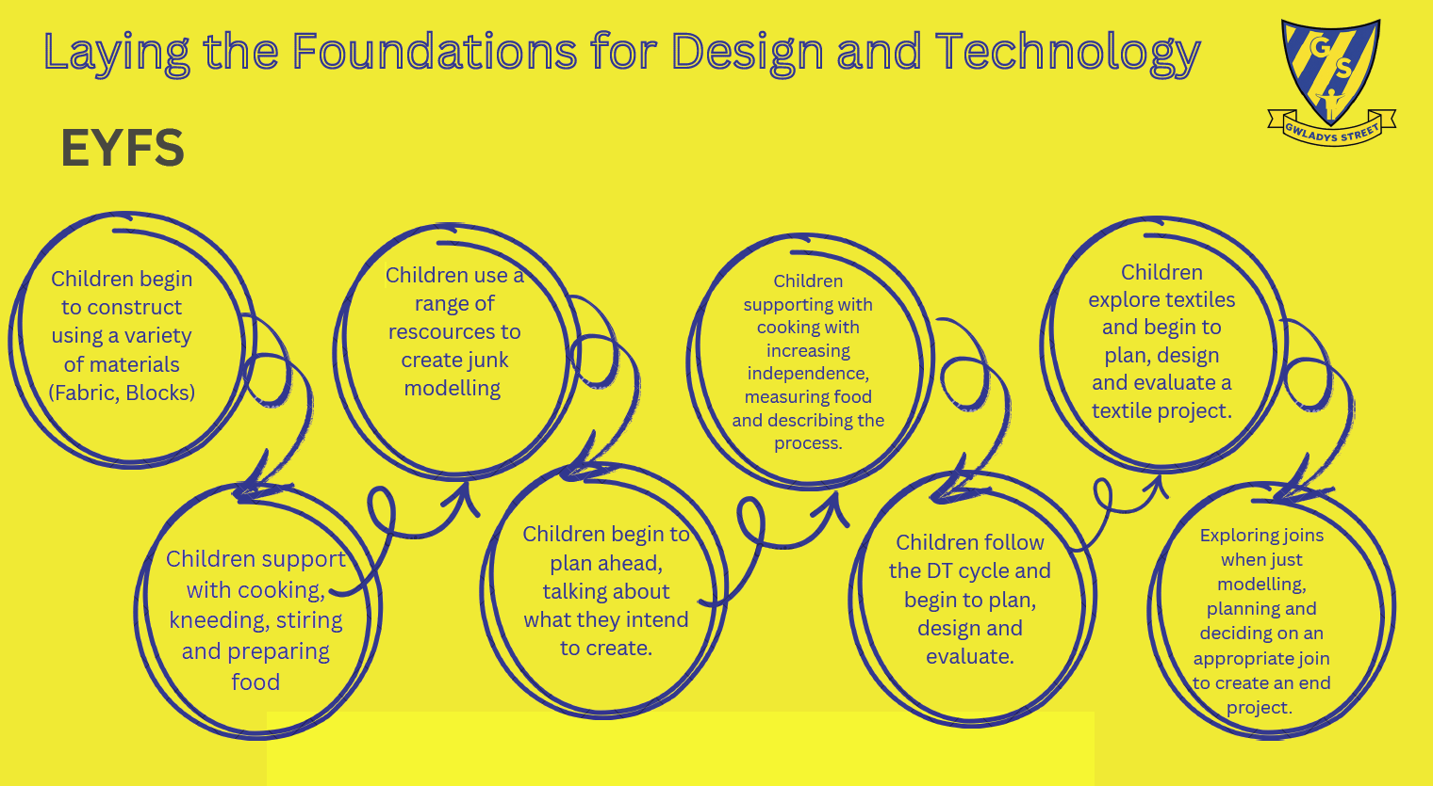

- Design and Technology Curriculum Planning.
Design and Technology teaching at Gwladys Street is taught in accordance with the National Curriculum (2014) and is delivered through the Kapow Primary Design & Technology scheme of work. Kapow provides a carefully sequenced curriculum that ensures clear progression in skills, knowledge and vocabulary from EYFS to Year 6. The Kapow scheme is organized into the following key strands: - Designing – Making – Evaluating – Technical knowledge – Cooking and nutrition. Units are carefully planned to build progressively across all year groups, revisiting and deepening prior knowledge.

Teaching and learning in Design and Technology follows the Kapow Primary pedagogy, which places emphasis on practical exploration, creativity and purposeful outcomes. Lessons are structured to support pupils through the full design process. Teachers use Kapow lesson plans, resources and guidance to ensure consistency and progression across the school. Skills and vocabulary are modelled explicitly, and pupils are encouraged to reflect on their learning throughout each unit.

KS1 - Long-term planning 2025-2026
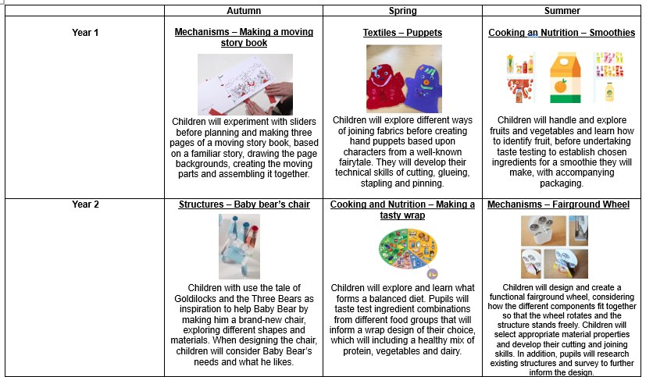

KS2- Long-term planning 2025-2026
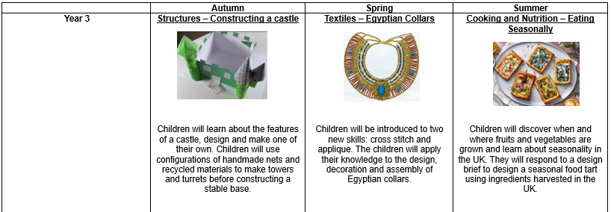
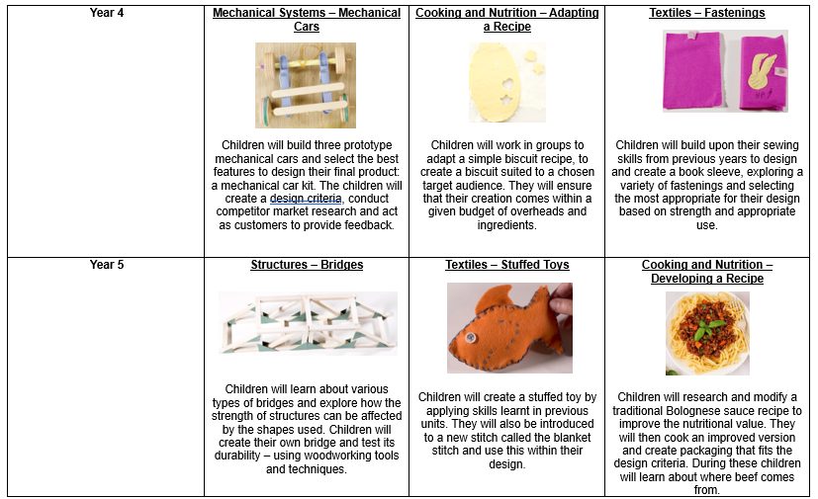
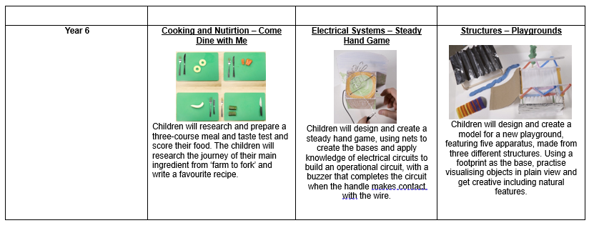
- Curriculum Links.
Design and Technology also provides children with opportunities for cross curricular links in other subject areas such as Science, Mathematics and Technology providing STEM opportunities. Design and Technology allows children to be creative, solve problems using mathematical enquiry, learn about materials and processes, make things with different materials and learn about the effects of products on the environment and on people. Design and Technology allows for children to apply their knowledge from other subject areas, bringing learning to life and motivating children within these other curriculum areas. Computing is an integral part of Design and Technology. It supports pupils with the design process and children can use software to enhance their skills in designing and making. Children can use draw and paint programs to model their ideas. Children can also use technology to collect information and carry out research in specific tasks as part of the design and research process. Children are introduced to careers linked to design, engineering, architecture, food technology, manufacturing and digital technologies to help them understand how learning Design and Technology can lead to future opportunities. Through Design and Technology, pupils learn to take risks, become resourceful, innovative and enterprising whilst developing an understanding of the wider world. In addition, children are encouraged to consider sustainability, environmental impact and responsible use of resources when designing and evaluating products.

- Design and Technology Inclusion.
At our school, we teach Design and Technology to all children whatever their ability and individual needs. Design and Technology is part of our whole school curriculum to provide a broad and balanced education to all children. Through the teaching of Design and Technology, we are able to provide many learning opportunities, which enable all pupils to make good progress. We strive hard to meet the needs of those pupils with special educational needs, those with disabilities, those with special gifts and talents, and those learning English as an additional language, and we take all reasonable steps to achieve this. The curriculum reflects diverse designers, inventors and technological achievements from different cultures, genders and backgrounds, ensuring all pupils can see themselves represented within the subject.
When progress falls significantly outside the expected range, the child may have special educational needs. Our assessment process looks at a range of factors – classroom organisation, the teaching materials, teaching styles and levels of support – so that action can be taken to enable the child to learn more effectively. Assessment using the National Curriculum and teacher judgements for Design and Technology allows us to consider each child’s attainment and progress against expected levels. This is then recorded onto O Track termly. We can then ensure that teaching is carefully adapted to the child’s needs.
We enable all pupils to have full access to the full range of activities involved in the designing, making and evaluating process of Design and Technology. Where children are to participate in activities or visits outside the classroom, we carry out a risk assessment prior to the visit, to ensure that the visit is safe and appropriate for all pupils.

- Assessment.
Assessment is an integral part of the National Curriculum and in relation to Design and Technology, teachers should assess pupil’s achievements and their knowledge through the progression of skills covered in each year group. Assessment of Design and Technology should look at the child’s ability to design, make, evaluate and their use of technical language. Assessment judgements are completed termly and recorded on O Track using the following judgements and symbols; Below (BLW) Working Towards (WTS) Expected (EXP). Assessment in Design and Technology is ongoing and formative and is supported by Kapow Primary assessment guidance. Teachers assess pupils’ learning through observation of practical work, discussion and questioning, and design evaluations and reflections. Kapow’s end-of-unit knowledge checks and skill-based outcomes support teachers in identifying what pupils know, can do and remember. Assessment information is used to inform planning, support progression and identify pupils who may need additional support. Each lesson has a set of key vocabulary which must be taught to the children. Here, children learn the meaning of technical vocabulary which they can use in their own work. Vocabulary is then revisited in each lesson to check understanding.

- Monitoring.
The monitoring of the standards of children’s work and of the quality of teaching in Design and Technology is the responsibility of the subject leader. The work of the subject leader also involves supporting colleagues in their teaching, being informed about current developments in Design and Technology and providing online and external support. The subject leader reviews and evaluates the action plan, assessment and effectiveness of teaching and use of ‘projects on a page’ regularly through regular book looks and checks on Seesaw. The subject leader also monitors and updates resources regularly and orders new resources when appropriate to do so. In addition to this, pupil and staff voice, learning walks, planning scrutiny and assessment analysis are also carried out regularly by the subject leader. Monitoring focuses on how well pupils know more and remember more over time through pupil discussions, assessment analysis and review of completed projects.

- Resources.
Children at Gwladys Street have access to a wide range of resources in order to support the teaching and learning of Design and Technology. A central store of resources is readily available in the Design and Technology area, which is a part of the resource room based in KS2 building. Resources for cookery are stored in the breakfast room. EYFS also has continued access to various resources both in the indoor and outdoor provision to support their knowledge and understanding of the world around them. The subject leader will maintain and audit these resources once a term. Specific items should be requested from the subject leader with plenty of notice of the new topic. It is the class teachers' responsibility to ensure kits, tools and equipment are returned to the cupboard they were found in a complete state or notify the subject leader of any deficiency. The school provides a range of appropriate tools, equipment and consumable materials to support the delivery of the Kapow Primary Design and Technology curriculum. Resources are selected to match the requirements of Kapow units and ensure that all aspects of the curriculum can be delivered effectively. Resources are audited regularly by the subject leader, stored safely and centrally, and replenished annually in line with curriculum needs, Kapow unit requirements and allocated budgets.
- Health and Safety.
The health and safety of all children at Gwladys Street is paramount at all times. Children will be taught how to care for and handle equipment safely and with respect in line with Gwladys Street’s Health and Safety policy. As a school, we follow the advice from CLEAPPS, an organisation that supports practical work in science, D&T and Art. Teachers will also refer to the Design and Technology risk assessment in which hazards and risks relating to Design and Technology are laid out comprehensively. Each class will have their own copy of the risk assessment. These risk assessments are updated regularly and in accordance with advice as directed by CLEAPPS. The class teacher must deliver training for Teaching Assistants and other adults, in use of certain tools, prior to the lesson and all should understand safe practices. When working with food, teachers and support staff should ensure areas are kept extremely clean and children are aware of simple personal hygiene rules. Tools, which present a safety hazard, such as a glue gun or a craft knife, need to be secured away from general tools. Children need to be trained and directed on how to use tools properly and in line with the Health and Safety Policy.

