Key Stage 1
 | Autumn | Spring | Summer
Year 1 | Mechanisms – Making a moving story book  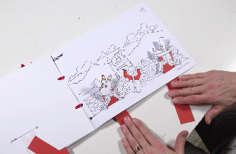  Children will experiment with sliders before planning and making three pages of a moving story book, based on a familiar story, drawing the page backgrounds, creating the moving parts and assembling it together. | Textiles – Puppets  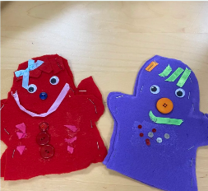  Children will explore different ways of joining fabrics before creating hand puppets based upon characters from a well-known fairytale. They will develop their technical skills of cutting, glueing, stapling and pinning. | Cooking an Nutrition – Smoothies  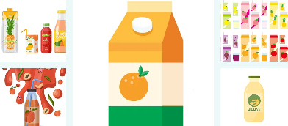  Children will handle and explore fruits and vegetables and learn how to identify fruit, before undertaking taste testing to establish chosen ingredients for a smoothie they will make, with accompanying packaging.
Year 2 | Structures – Baby bear’s chair  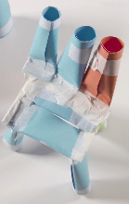  Children with use the tale of Goldilocks and the Three Bears as inspiration to help Baby Bear by making him a brand-new chair, exploring different shapes and materials. When designing the chair, children will consider Baby Bear’s needs and what he likes. | Cooking and Nutrition – Making a tasty wrap  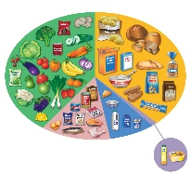  Children will explore and learn what forms a balanced diet. Pupils will taste test ingredient combinations from different food groups that will inform a wrap design of their choice, which will including a healthy mix of protein, vegetables and dairy. | Mechanisms – Fairground Wheel  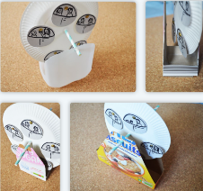  Children will design and create a functional fairground wheel, considering how the different components fit together so that the wheel rotates and the structure stands freely. Children will select appropriate material properties and develop their cutting and joining skills. In addition, pupils will research existing structures and survey to further inform the design.

Key Stage 2
 | Autumn | Spring | Summer
Year 3 | Structures – Constructing a castle  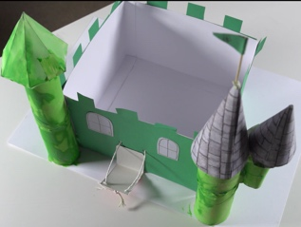  Children will learn about the features of a castle, design and make one of their own. Children will use configurations of handmade nets and recycled materials to make towers and turrets before constructing a stable base. | Textiles – Egyptian Collars  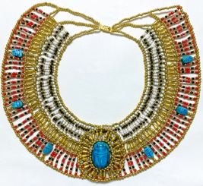  Children will be introduced to two new skills: cross stitch and applique. The children will apply their knowledge to the design, decoration and assembly of Egyptian collars. | Cooking and Nutrition – Eating Seasonally  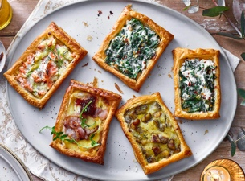  Children will discover when and where fruits and vegetables are grown and learn about seasonality in the UK. They will respond to a design brief to design a seasonal food tart using ingredients harvested in the UK.
Year 4 | Mechanical Systems – Mechanical Cars  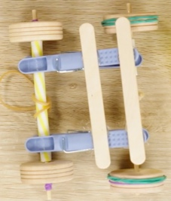  Children will build three prototype mechanical cars and select the best features to design their final product: a mechanical car kit. The children will create a design criteria, conduct competitor market research and act as customers to provide feedback. | Cooking and Nutrition – Adapting a Recipe  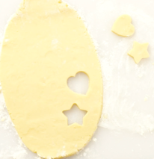  Children will work in groups to adapt a simple biscuit recipe, to create a biscuit suited to a chosen target audience. They will ensure that their creation comes within a given budget of overheads and ingredients. | Textiles – Fastenings  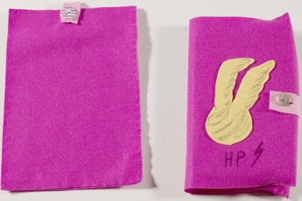  Children will build upon their sewing skills from previous years to design and create a book sleeve, exploring a variety of fastenings and selecting the most appropriate for their design based on strength and appropriate use.
Year 5 | 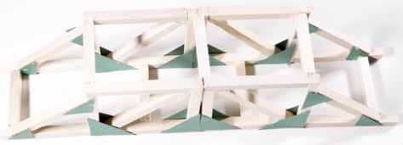  Structures – Bridges  Children will learn about various types of bridges and explore how the strength of structures can be affected by the shapes used. Children will create their own bridge and test its durability – using woodworking tools and techniques. | Textiles – Stuffed Toys  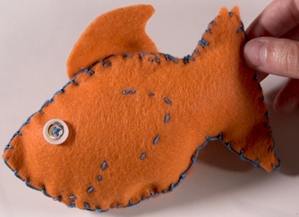  Children will create a stuffed toy by applying skills learnt in previous units. They will also be introduced to a new stitch called the blanket stitch and use this within their design. | Cooking and Nutrition – Developing a Recipe  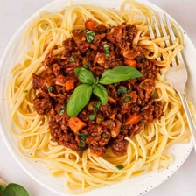  Children will research and modify a traditional Bolognese sauce recipe to improve the nutritional value. They will then cook an improved version and create packaging that fits the design criteria. During these children will learn about where beef comes from.
Year 6 | Cooking and Nutirtion – Come Dine with Me  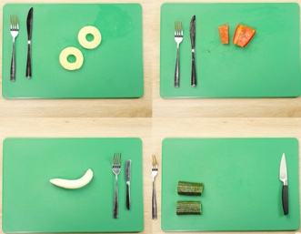  Children will research and prepare a three-course meal and taste test and score their food. The children will research the journey of their main ingredient from ‘farm to fork’ and write a favourite recipe. | Electrical Systems – Steady Hand Game  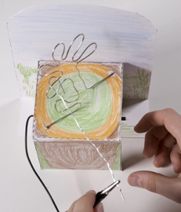  Children will design and create a steady hand game, using nets to create the bases and apply knowledge of electrical circuits to build an operational circuit, with a buzzer that completes the circuit when the handle makes contact with the wire. | 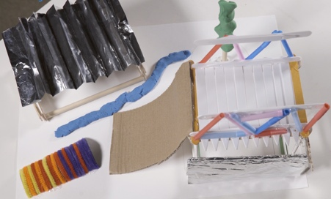  Structures – Playgrounds  Children will design and create a model for a new playground, featuring five apparatus, made from three different structures. Using a footprint as the base, practise visualising objects in plain view and get creative including natural features.

