Geography Policy 2025-2026

Gwladys Street CP & Nursery School

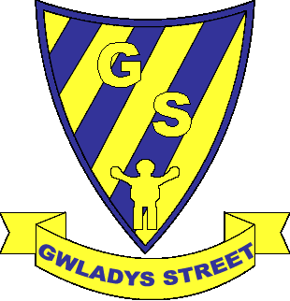

Approved by: |  | Date: March 2026
Last reviewed on: | [N/A]
Next review due by: | September 2026

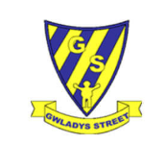
Geography at Gwladys Street Community Primary and Nursery School

At Gwladys Street we are determined that every pupil will have the opportunity to be a geographer; we do not see background, needs or abilities as insurmountable barriers to learning. We want them to have no limits to what their ambitions are and grow up wanting to be cartographers, town planners, conservationists or weather forecasters. The geography curriculum has been structured so that our children develop their geographical skills and knowledge by building upon prior learning. We want our children to remember their geography lessons in our school, we want them to retain knowledge of key facts and vocabulary so that they have a foundation for their continued school life and life beyond school.
Intent

At Gwladys Street, we would like to ensure all children leave with an enthusiasm for Geography, rooted in an understanding of the human and physical geographical processes. We aim to do this by:
- Inspiring pupils to become curious and explorative thinkers with a diverse knowledge of the world.
- Developing the confidence to question and observe places, measure and record necessary data in various ways, and analyse and present their findings.
- Building an awareness of how Geography shapes our lives at multiple scales and over time.
- Encouraging pupils to become resourceful, active citizens who will have the skills to contribute to and improve the world around them.

Implementation

Through focused teaching, we ensure our geographers show the following characteristics:
- Compare and contrast human and physical features to describe and understand similarities and differences between various places in the UK, Europe and the Americas.
- Name, locate and understand where and why the physical elements of our world are located and how they interact, including processes over time relating to climate, biomes, natural disasters and the water cycle.
- Understand how humans use the land for economic and trading purposes, including how the distribution of natural resources has shaped this.
- Develop an appreciation for how humans are impacted by and have evolved around the physical geography surrounding them and how humans have had an impact on the environment, both positive and negative.
- Develop a sense of location and place around the UK and some areas of the wider world using the eight-points of a compass, four and six-figure grid references, symbols and keys on maps, globes, atlases, aerial photographs and digital mapping.
- Identify and understand how various elements of our globe create positioning, including latitude, longitude, the hemispheres, the tropics and how time zones work, including night and day.
- Present and answer their own geographical enquiries using planned and specifically chosen methodologies, collected data and digital technologies.

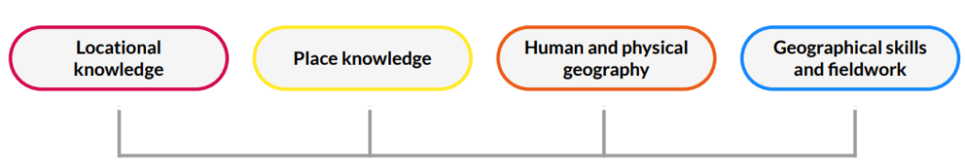

Taken from Kapow’s Geography Three_Is document 21.03.23

Impact

Our aim is that children can develop a curiosity, appreciation and respect for the world around them. As inspired geographers, children will be able to build an understanding of the interconnection between human and the physical features. Through our learning, geographers will be able to compare and contrast human and physical features and identify and describe the similarities and differences between various locations around the world. Build an understanding of processes over time (including: climate, natural disasters and the water cycle). Children will be able to understand how humans use the land. Children will be given the opportunity to develop an appreciation for humans have impacted the environment. Furthermore, children will be given the opportunity to develop a sense of location and place within the UK and more globally using symbols and keys on maps, globes, atlases and aerial photographs.

EYFS
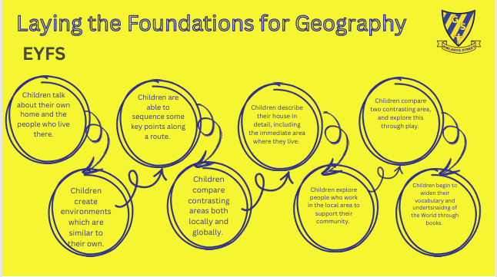
In the Early Years, geographical themes are explored through the 'Understanding the World' strand of the EYFS curriculum. This involves guiding children to develop a sense of place and community through hands-on experiences, observation, and discussion.

Key Stage 1

In Key Stage 1 we follow Kapow Primary’s Geography scheme of work. This scheme aims to inspire pupils to become curious and explorative thinkers with a diverse knowledge of the world; in other words, to think like a geographer. We want pupils to develop the confidence to question and observe places, measure and record necessary data in various ways, and analyse and present their findings. Through our scheme of work, we aim to build an awareness of how Geography shapes our lives at multiple scales and over time. We hope to encourage pupils to become resourceful, active citizens who will have the skills to contribute to and improve the world around them.

Kapow encourages:
• A strong focus on developing both geographical skills and knowledge.
• Critical thinking, with the ability to ask perceptive questions and explain and analyse evidence.
• The development of fieldwork skills across each year group.
• A deep interest and knowledge of pupils’ locality and how it differs from other areas of the world.
• A growing understanding of geographical concepts, terms and vocabulary.
Kapow Primary’s Geography scheme of work enables pupils to meet the end of key stage attainment targets in the National curriculum. The aims also align with those in the National curriculum.
The National curriculum organises the geography attainment targets under four subheadings or strands:
• Locational knowledge
• Place knowledge
• Human and physical geography
• Geographical skills and fieldwork
Kapow Primary’s Geography scheme has a clear progression of skills and knowledge within these four strands across each year group.
Cross-curricular links are included throughout each unit, allowing children to make connections and apply their Geography skills to other areas of learning. Our enquiry questions form the basis for our key stage 1 units, meaning that pupils gain a solid understanding of geographical knowledge and skills by applying them to answer enquiry questions.
Each unit contains elements of geographical skills and fieldwork to ensure that fieldwork skills are practised as often as possible. Kapow Primary units follow an enquiry cycle that maps out the fieldwork process of question, observe, measure, record, and present, to reflect the elements mentioned in the National curriculum. This ensures children will learn how to decide on an area of enquiry, plan to measure data using a range of methods, capture the data and present it to a range of appropriate stakeholders in various formats.
Fieldwork includes smaller opportunities on the school grounds to larger-scale visits to investigate physical and human features. Developing fieldwork skills within the school environment and revisiting them in multiple units enables pupils to consolidate their understanding of various methods. It also gives children the confidence to evaluate methodologies without always having to leave the school grounds and do so within the confines of a familiar place. This makes fieldwork regular and accessible while giving children a thorough understanding of their locality, providing a solid foundation when comparing it with other places.
Lessons incorporate various teaching strategies from independent tasks to paired and group work, including practical hands-on and collaborative tasks. This variety means that lessons are engaging and appeal to those with a variety of learning styles. Each lesson provides guidance for teachers on how to adapt their teaching to ensure that all pupils can access learning, and opportunities to stretch pupils’ learning are also available if required. Knowledge organisers for each unit support pupils in building a foundation of factual knowledge by encouraging recall of key facts and vocabulary.
Strong subject knowledge is vital for staff to deliver a highly effective and robust Geography curriculum. Each unit of lessons includes multiple teacher videos to develop subject knowledge and support CPD. Kapow Primary has been created with the understanding that many teachers do not feel confident delivering the full Geography curriculum, and every effort has been made to ensure that they feel supported to deliver lessons of a high standard that ensure pupil progression.

Key Stage 2

At Gwladys Street Community Primary and Nursery School, we follow the Opening Worlds curriculum for Geography throughout Key Stage 2. The Opening Worlds curriculum is carefully sequenced, knowledge rich and contains high quality vocabulary. Pupils need to have the accessed the previous year group's learning in order to be successful and rise to the challenge of understanding the content and using geographical skills. The curriculum ensures that clear cross curricular links are made and that the knowledge and skills learned are thoughtfully retrieved in each session.
This knowledge-rich curriculum is mapped to meet and exceed the requirements of the National Curriculum.
- Substantive Knowledge: The curriculum ensures full coverage of locational knowledge, place studies, and human and physical geography. Pupils explore the UK, Europe, and the Americas through rigorous case studies, such as the study of Alpine regions and the Amazon Basin.
- Disciplinary Skills: Opening Worlds integrates the development of geographical skills, including the use of maps, atlases, and digital mapping. It provides a structured approach to fieldwork, enabling pupils to collect, analyse, and communicate data effectively.
- Sequencing and Progression: The curriculum is built on 'strong vertical sequencing.' Concepts (such as settlement, trade, and climate) and specialized vocabulary are systematically revisited and deepened from Year 3 through to Year 6 to ensure long-term retention and high-level outcomes.

Fieldwork and Geographical Enquiry

Fieldwork is integral to our geography curriculum, providing pupils with first-hand experiences to apply their classroom learning to the real world.
- Integrated Enquiry: We follow the Opening Worlds approach, where fieldwork is not a standalone activity but is integrated into specific units to deepen understanding (e.g., studying local rivers in Year 3 or urban land use in Year 6).
- Progression of Skills: Fieldwork opportunities are mapped to ensure a clear progression in procedural knowledge. This includes:
    - Data Collection: Using various techniques such as sketching, observational tallies, and digital mapping.
    - Analysis and Communication: Moving from simple observations in Lower KS2 to more complex data analysis and justified conclusions in Upper KS2.
    - Local and Contrasting Environments: Pupils utilise the school grounds and immediate locality for regular enquiry, with planned opportunities to visit contrasting environments to compare human and physical features.

Long Term Planning 2025-2026
Key Stage 1
Kapow
 | Autumn | Spring | Summer
Year 1 | What is it like here?  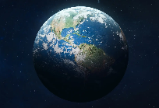  Children will locate features on an aerial photograph of our school. They will know the name of the country and city in which we live. They will make a map of their classroom with key features, using objects to represent the distance and direction of features in the classroom. They will recognise features in the school grounds using a map. | 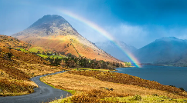  What is the weather like in the UK?  Children learn to identify and locate the four UK countries, recognise their own country and describe locations using basic compass directions. They also measure different types of weather, using symbols used in weather forecasts, describe seasonal changes and suggest appropriate clothing and activities for each season. | 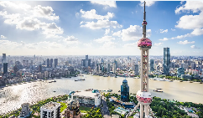  What is it like to live in Shanghai?  Children will be able to give examples of human and physical features. They will use an atlas to locate the UK, China, Europe and Asia on a world map. Children will compare Shanghai to Liverpool.
Year 2 | Would you prefer to live in a hot or cold place?  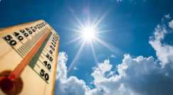  Children will learn and locate the seven continents on a world map, along with the North and South Poles. They will recognise the features of hot and cold places and will locate some countries with hot or cold climates on a world map. |   Why is our world wonderful?  This unit will give the children knowledge to explain the difference between oceans and seas. Children will identify and locate characteristics of the UK on a map and will name and locate the five oceans on a world map. | What is it like to live by the coast?  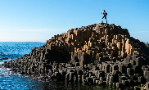  In this unit children will name and locate the seas and oceans surrounding the UK in an atlas and be able to label these on a map of the UK. This unit will help children define what the coast is, and they will be able to locate coasts in the UK and name some of the physical features of coasts.

Long Term Plan 2025-2026
Key Stage 2
Opening Worlds

 | Autumn 1 | Autumn 2 | Spring 1 | Spring 2 | Summer 1 | Summer 2
Y3 | Rivers  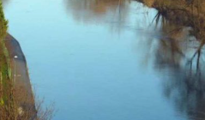  The River Indus - its source, course, human interactions with environment. How rivers get their water - the source, springs, the water cycle. How do rivers shape the land? The river’s load. Flooding: River Severn (Wildlife in the River Severn).  Geographical skills: Using photographs. | Mountains  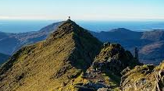  Highest mountain in each of the four countries of the UK.  Mountain ranges and mountainous regions: Brecon Beacons, Highlands, Lake District, Snowdonia, Pennines, Yorkshire Dales.  Why do people live on mountains?  Relationship between mountains and weather.  Relationship between mountains and people.  Geographical skills: Describing location using 4-point compass | Settlements    Settlement types, hamlet, village, town, city etc; land use, settlements by rivers. Major cities in the UK – locational overview. London as a conurbation and London boroughs.  Two cities: Cardiff and London, including economy & transport. How do people move about in Cardiff?  How do people move about in London?  Patterns of settlement in Cardiff and London. | Agriculture  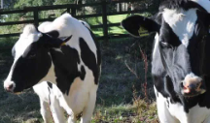  Arable farming, pastoral farming, mixed farming, how farming changes the landscape.  How the food we eat affects farming (seasonal food, local food, pesticides, organic food, vegetarian and plant-based diets that do not use animals.  Sheep farming in Wales – Snowdonia.  Locational knowledge revisited: Wales, Snowdonia, Gloucestershire. New locational knowledge: Sussex  Geographical theme: links between food consumption patterns and farming; issues arising e.g. local sourcing.  Geographical skills: Optional local fieldwork on local shops – their sourcing, economic and ethical considerations. | Volcanoes  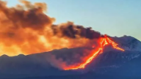  Structure and composition of the earth.  How and why volcanoes erupt.  Types of volcanoes Active, dormant and extinct volcanoes.  Why people visit volcanoes (work, tourism, farming, science) .  Geographical skills: Using diagrams, describing distribution. | Climate and biomes  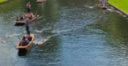  Continent of Europe.  Climate zones - first mention of Equator, Arctic, Antarctic and the North/South poles.  Climate and relationship with oceans.  Climate and biomes within climates.  Geographical skills: World map and key lines of latitude.
Y4 | 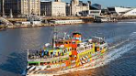  The River Mersey  Where the River Mersey is in the UK. Where the River Mersey Flows: Greater Manchester and Liverpool into the Irish Sea  Key settlements along the river  River features: Source, mouth, estuary  The Mersey Estuary  How rivers shape the land (erosion, transport, deposition)  Importance of the river for:  Trade and transport (historically and today)  The growth of Liverpool as a port  Land use along the river (industry, housing, docks)  Environmental issues (pollution, regeneration)  Interconnection  How the river influenced settlement and industry.  How humans have changed the river environment.  Geographical skills:  Locate the River Mersey on UK maps  Identify cities, estuary, and surrounding areas  Compare the Mersey with another river (e.g. size, use, location). | Population  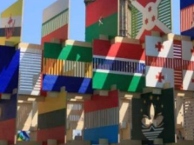  Characteristics of population including distribution and diversity. Migration.  Depth focus: multicultural London. Depth focus: multicultural Cardiff.  Welsh language and culture, effect of changing demographics.  Welsh or British? Idea of national identity.  Geographical skills: Thematic maps and using census data. | 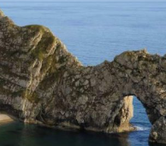  Costal process and landforms  Diversity in the UK coastline.  Processes of erosion, transportation & deposition.  Coastal landforms including beaches, headlands and bays.  Overview of Jurassic coast, including significance of its rocks, fossils and landforms.  Coastal habitats using contrasting examples, including coasts of the Indian Ocean.  Depth focus: West Wales coast. | Tourism  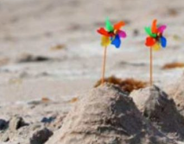  Llandudno, Wales - a seaside town (link back to coastal processes in previous unit).  Types of tourism (e.g. visiting friends and family activity holidays). Skiing holidays in the Alps.  The growth of tourism in the UK and overseas. Sunshine holidays in Spain.  Advantages and disadvantages of tourism.  Sustainable tourism.  Geographical skills: Interpreting climate data. | Earthquakes  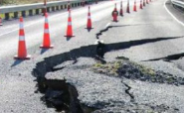  In depth focus: The Christchurch earthquake, New Zealand.  Causes of earthquakes: tectonic plates, fault lines Depth focus: California & San Andreas fault, Indian Ocean tsunami.  Effects of earthquakes How humans live in earthquake zones and adapt their settlements (e.g. Japan).  Revisits knowledge on volcanoes from Year 4 Spring 1.  Geographical skills: Thematic maps | Deserts  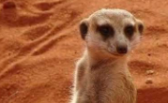  Distribution and climate of deserts  In depth focus: The Sahara Desert How deserts are formed, variety of landscapes.  Plants and animals in deserts How humans live and adapt in deserts.  In depth focus: The Patagonian Desert.  Geographical skills: Interpreting thematic maps and satellite photographs.
Y5 | 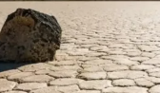  Why is California so thirsty?  Water as a resource  In depth focus on California (region in North America), continuing natural resources theme (revisit water cycle from Year 3).  Water resources in California Farming - intensive farming, growing almonds California aqueduct – providing water.  The future of water supply in California.  Geographical skills: Interpreting a range of thematic maps. | Oceans  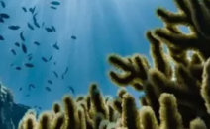  Locational framework – world oceans, seas in Europe.  Oceans and trade, oceans and climate, major currents.  Oceans and the land masses we’ve studied in depth – the Atlantic and West Wales.  The Pacific and South America.  Oceans and climate change, the human impact on oceans.  Geographical skills: Interpreting world and thematic maps. | Migration  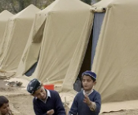  Real migration stories in people’s own words, from Northern Ireland to Liverpool and from Turkey to London.  Why do people migrate?  Push and pull factors revisited (from Year 5 Autumn 1) and extended in new contexts.  Refugees, persecution, asylum, asylum seekers; challenges for refugees.  How does migration change places?  London, Shetland Islands, Cambridgeshire Migration and identity: examples from diverse settings showing complexity of identity, dual nationalities, multiple identities, and the role of place in identity.  Understanding place in relation to scale.  Geographical skills: Asking questions, eight-point compass. | North and South America  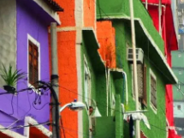  Human and physical characteristics of North and South America, including population distribution and climate.  Megacities including Lima and depth focus on Brazil’s megacities.  Urban-rural migration in Brazil, including informal settlements, like favelas.  Challenge stereotypes often held of the favelas.  Geographical skills: 4-figure references, thematic maps. | The Amazon  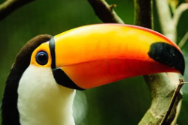  An in depth focus on the Amazon as a region in South America, including conversations between UK children and children from the Bolivian Amazon.  The Amazon river – course and characteristics.  The Amazon ecosystem – vegetation, animals and food chains. Ecosystem processes. Causes and effects of deforestation.  Futures for the Amazon rainforest.  Geographical skills: Flow diagrams, interpreting satellite photos. | Interconnected Amazon  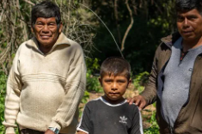  Farming in the Amazon: depth focus on the Bolivian Amazon (starting with the same community as in Summer 1).  The journey of soy produced in Bolivia.  Primary, secondary, and tertiary industry.  International trade.  Effects of changes in trade.  Trans-national companies.  Environmental connections, carbon cycle, impacts of deforestation. Social connections, globalisation.  Geographical skills: Interpreting and drawing bar graphs, simple enquiry process, questionnaire.
Y6 | 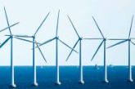  Energy and Climate Change  How people use energy Types of energy.  Renewable and non-renewable energy sources.  The greenhouse effect. Enhanced greenhouse effect – causes (including energy use and farming).  Climate change and its effects (building on earlier work on oceans and interconnection) examples from Antarctica, Great Barrier Reef, Pacific Islands, South Asia, UK.  How can we respond?  Geographical skills focus: Interpreting line graphs. | Ethiopia  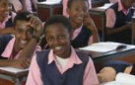  Where is Ethiopia?  Location in Africa (introduction only as this continent is a focus in KS3)  What is Ethiopia like?  Climate, landscape (including Great Rift Valley), population, biomes, major cities, rural life.  Sustainable futures – challenges faced due to climate change, UN sustainable development goals, depth focus on one project.  Geographical skills focus: Population. . | Changing Liverpool  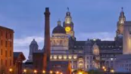  This unit reviews and extends knowledge of cities in the UK, focusing on past, present and future changes.  Where is Liverpool? How has it changed in the past? Growth and development of the city, industry, migration, deindustrialisation, redevelopment How is it changing now?  What might Liverpool be like in the future?  Possible, probable, and preferable futures.  Geographical skills: Interpretation and presentation of data. | Jamaica  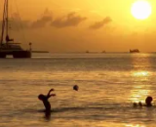  An in-depth place focus to complement other regions studied in North and South America (California, the Amazon) and to link with themes in History.  Where is Jamaica?  Reinforcing knowledge gained about the world, including time zones, and developing understanding of the Caribbean.  What is Jamaica like?  Climate, landscape, population history, migration, ocean biomes.  Tourist industry.  Sustainable futures – environmental challenges faced due to tourism, ways forward. | Fieldwork  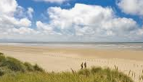  How do geographers find out about a place?  Ordnance survey maps, revision of symbols, 8-point compass and four-figure grid references, extending to 6-figure grid references. Interpreting a range of maps and data, bringing together skills from all topics in KS2 (e.g. atlases, thematic maps, digital technologies)  What questions can we ask about the local area? Setting up a fieldwork enquiry and going through the stages of the enquiry process (asking questions, collecting data, analysing data, presenting findings). Geographical skills: Ordnance survey maps, 6-figure grid references, enquiry process, local-area fieldwork Disciplinary focus: How geographers investigate a place. | Fieldwork  How do geographers find out about a place?  Ordnance survey maps, revision of symbols, 8-point compass and four-figure grid references, extending to 6-figure grid references. Interpreting a range of maps and data, bringing together skills from all topics in KS2 (e.g. atlases, thematic maps, digital technologies)  What questions can we ask about the local area? Setting up a fieldwork enquiry and going through the stages of the enquiry process (asking questions, collecting data, analysing data, presenting findings). Geographical skills: Ordnance survey maps, 6-figure grid references, enquiry process, local-area fieldwork Disciplinary focus: How geographers investigate a place.

Record keeping, Assessment and Recording

Teachers will assess children’s Geography work in a variety of ways to ensure they gain a full understanding of what each child has learnt, and what is needed to progress in their learning. Teachers will observe, provide written and oral feedback. Progression in geography is discussed in staff and moderation/standardisation meetings internally and externally. In addition, teacher assessments are recorded termly using the school’s assessment policy. Class teachers should keep records of work carried out, and levels of achievement of the work. Written work and photographs of practical lessons are useful, as a reminder of pupil’s achievement. Photographs are uploaded onto SeeSaw to celebrate and showcase children’s Geography work. Both Kapow Primary and Opening World schemes recommends that the assessment of pupils is formative based on pupil outcomes and questioning from each lesson. The following can be used to assess pupils’ knowledge and application of skills and their understanding and use of vocabulary. The best form of assessment in Geography is in-action, while pupils are working. This helps us to understand pupils’ understanding and offers the teachers opportunity to support or challenge pupils. By encouraging pupils to articulate their thinking and application of skills, we can understand which aspects of geographical aspects they may require additional teaching in and reshape teaching to support this.
In Key Stage 2 After the sixth lesson of each unit, pupils do an extended, synoptic task. This is often a piece of extended writing. It might also be an annotated diagram or a more creative outcome such as a story about the past or a little problem to solve using their historical or geographical knowledge. These extended tasks allow pupils both to further develop and to demonstrate, their new knowledge, both substantive and disciplinary, from the unit of work.

Roles and Responsibilities
At Gwladys Street the Geography Subject Leader is responsible for:
- Providing leadership and vision
- Updating the Geography policy
- Monitoring the implementation of Geography schemes (Kapow Primary and Opening Worlds)
- Writing and implementing the geography action plan
- Supporting staff with delivery of the curriculum and assessment
- Delivering staff meetings and training
- Audit and maintain resources

Monitoring
Monitoring the impact of teaching and learning is carried out regularly by the subject leader. This consists of:
- Learning walks and Lesson Observations
- Monitoring and scrutiny of Geography books
- Pupil Voice
- Teacher Voice
- Staff training sessions for teachers and support staff

Cross-Curricular Links
Children will collect and analyse data from a range of sources and communicate this in a variety of ways, including maps, numbers and writing. Where possible, the study of this subject is cross-curricular, and children are provided with an understanding of what it means to be a global citizen. This will encourage a respect for other cultures and the environment. Geography is delivered through discrete units throughout the school. Where appropriate, cross curricular links are made with other subjects. For example, children read and interpret graphs in Maths. Grid references, map skills and orienteering also use mathematical knowledge and link to P.E. Links to History are made through the study of World War 2 mapping the conflict in Europe.
Reasonable adjustments for pupils with SEND
As part of the planning and preparation for the delivery of each unit from Kapow Primary and Opening Worlds, teachers will need to consider how specific activities, or the delivery may need to be adjusted to ensure that pupils with SEND are able to access the materials and participate fully in the lesson. Pupils with language and communication difficulties (including those with ASD) may need additional visual prompts to help them understand what is expected of them. Some pupils may require individual tasks to enable them to follow a series of steps where a task has been broken down into smaller, more manageable chunks. Widgets for all Geography units have been created as visuals to help support children in their lessons.

Inclusion and Equal Opportunities
All teaching and non‐teaching staff at Gwladys Street Community Primary and Nursery School are responsible for ensuring that every pupil, regardless of gender, race, culture, background and ability have the opportunity to experience education at an appropriate and challenging level. To ensure that pupils experience high standards of success, Geography needs to be taught with regards to pupil’s abilities to ensure progress. We aim to identify and minimise barriers to learning and take account of gender, ability, disability, social, cultural, and linguistic background when planning lessons. Provision is made to enable all pupils to participate effectively in curriculum and assessment activities. A wide range of gender specific and cultural images that challenge stereotypes will be used. This policy ensures that certain aspects of Geography are not seen as more appropriate for boys or girls. Individual teachers consider carefully the groupings they have. These might depend on the experiences the children have had in their home environments. All children will be given access to Geography irrespective of race, gender, level of ability, religion, social background and culture. Mutual respect and tolerance for all cultures will be promoted through the study of Geography. Appropriate differentiation will allow all children to achieve and fulfil their potential in this subject. We teach Geography to all pupils, whatever their ability, in accordance with the information set out in our school curriculum overviews, providing a broad and balanced curriculum to all. Teachers provide learning opportunities matched to the needs of children of all capabilities, setting and reviewing appropriate targets.

Fieldwork and Health and Safety
All geography fieldwork, including local area studies, will be accompanied by a 'suitable and sufficient' risk assessment. This document will identify hazards, who might be harmed, and the control measures in place to reduce risk. This assessment must be completed and approved prior to the departure of any trip. When conducting fieldwork, children should be properly supervised and should be made aware of any potential dangers, such as busy roads or water hazards.

Vision
Our Vision Statement:
“To provide the stepping stones for a successful and fulfilling future with the Gwladys Street Family, celebrating generations of success.”
Our Aims – What Makes Gwladys Street Special:
We strive to create a school where:
- Learning Comes Alive – Every child experiences an exciting, creative, and challenging curriculum that inspires a lifelong love of learning.
- Happiness and Safety Are Key – Our school community is a place where everyone feels safe, valued, and supported to thrive.
- Partnerships Matter – We work hand-in-hand with our wider school community to support every child’s journey.
- Inclusion is at Our Heart – Golden in our welcoming and inclusive environment.
- Respect and Teamwork Shine – Together, we achieve our GOALS by fostering respect, collaboration, and kindness.
- Confident Minds Grow – We nurture independence, confidence, and a lively curiosity in every child.
- Healthy Living is Promoted – Our school embraces healthy lifestyles and nurtures positive, spiritual, and moral values.

